®

USER MANUAL

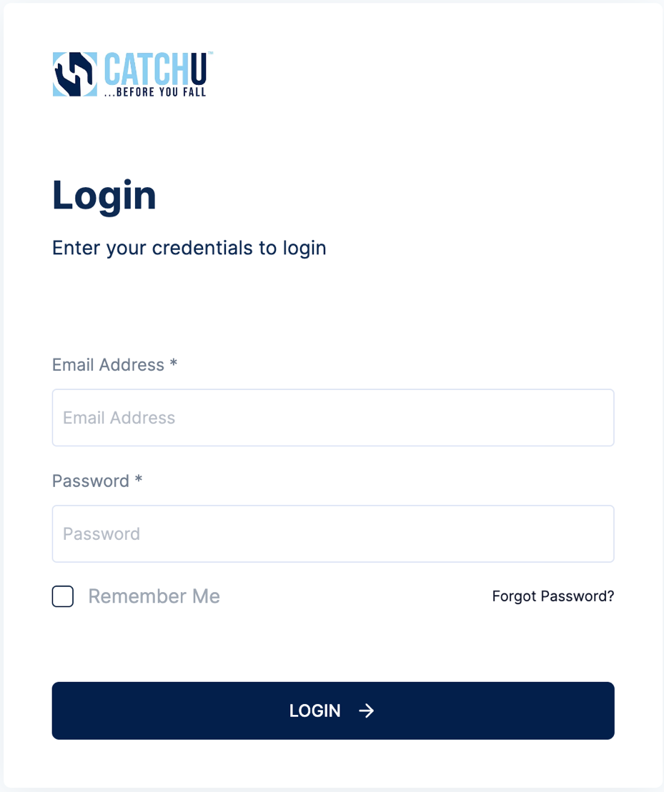

Table of Contents

Welcome to CatchU!.....…………………………………………………………………………3
- Creating a CatchU Account …….…………………………………………………......4
- Managing CatchU Account.....……………………………………………………..4-31
- Update Profile Information….……………………………………………………7-8
- Manage Communities (aka Practices).....………………………..……….....8-31
a. Manually add one new Community………………………..……..….…….....9-10
b. Import multiple Communities concurrently….………………..……….……10-12
    - Import using CatchU .csv file template.……….……..……..…………12
    - Import using existing .csv file………………….…..………..…….........12
- Update/Edit Community Information……………………..……..……...…..12-13
- View Community Information.......…………..……………………..…..……13-31
    - Patients Tab..….....…………………………..…..……..….............16-18
    - Users Tab...…………………………………..…..………………….18-22
    - iPhones List Tab..…..……………..……..…..………...................22-23
    - Billees Tab.……..………..…………..…..………………………….23-24
    - Providers Tab….………..……………..…..…………………….….25-28
    - Group Test History Tab......…..……… ………..…..………….…..28-31
- Manage Corporate Accounts……………………………….....……..……....32-38
        - Manually add one new corporate account………………….....…..………......32
        - Import multiple Corporate accounts concurrently…………………..…..…33-34
- Import using CatchU .csv file template……..…….…….……….…..…33
- Import using existing .csv file…...……………………………..……..…34
        - Update/Edit Corporate Information..…………………………………..……34-35
d. View Corporate Information ………………...…………………………....…35-38
- Audit Logs..….....……………..……..………………..………………..…….......39
- Ordering Tests…..……...………..……..………………..………………..….40-44
        - Tests to Schedule & Upcoming Tests - Left Side Toolbar..…………….......40
        - Ordering Tests from Patients Option - Left Side Toolbar.…....…..………....41
        - Ordering Tests the Community Option - Left Side Toolbar…..….……...…..42
        - Create Test…………………….……….…………...………..….……………....43
        - Initiate Test.……………….…………….……...………..….…………..……43-44
- CatchU iPhone App & Process…..….…………………………………..…………44-66
- Billing…..….……….....…….....………….…………………….………….....…….67-71
        - Creating a Bill.com account.…….………….……………………………...68
- Support….…………….....…….....………….………………….…………….………..72
- Glossary......……….……….....…….....………….………………….…………….73-75

Welcome to CatchU!

We are happy to be part of your practice or community and we thank you for allowing us to help screen your patients for potential fall risk. The ability to successfully integrate information across sensory systems is a vital aspect of functioning in the real world. To date, only a few studies have investigated the clinical value of multisensory integration in response to visual and somatosensory (aka touch) information. Our previous research has linked the magnitude of visual-somatosensory integration (measured behaviorally using simple reaction time tests) to important cognitive (attention) and motor (balance, gait, and falls) outcomes in healthy older adults.

We recently developed a step-by-step protocol for administering and calculating multisensory integration effects to facilitate innovative and novel translational research across diverse clinical populations and age ranges. However, patients with severe medical conditions and/or mobility limitations often have trouble traveling to research facilities or joining time-demanding performance-oriented mobility research studies. This led to the creation of CatchU®: a mobile fall risk tool to help clinicians and researchers gain access to multisensory assessments that can be utilized in clinical and remote settings. The impetus for creating CatchU, a mobile fall-risk tool designed for seniors, was to afford opportunities to assess and introduce personalized interventions to alleviate disability and maintain independence in older adults. The CatchU test is conducted on any iPhone version 7 (or newer) or Android (5.0 or newer) to ensure consistent vibratory information is presented to all users as our technology relies on Apple’s Taptic Engine.

In what follows, we provide detailed documentation regarding how to create an account and gain access to the portal after signing up for CatchU services. Note, we also have a quick reference guide on our website that provides quick-setup account information. Depending on the individual’s specific role (administrator, billee, etc.), staff will be able to register users, patients, physicians, and iPhones or Androids. Administrators may also order CatchU tests for patients (our portal is designed to send text messages with a downloadable link to the patient or caregiver’s iPhone or Android) and track the status of the ordered test. All of these concepts are defined further in what follows.

- Not all patients will have iPhones or Androids, but if they have a family member, neighbor, or friend with an iPhone 7 or higher or Android 5.0 or higher, the text message may be sent to any iPhone version 7 or newer or Android version 5.0 or higher.
- Alternatively, the practice or community may use an in-house iPhone (version 7 or newer) or Android (version 5.0 or newer) for patients to take onsite
  - Once the patient finishes the test, the provider (or administrator – depending on how each specific practice sets up the account) will receive a confidential test report as a .pdf file via email three days later, indicating the patient’s multisensory integration performance and their likelihood of a fall in the next year
  - Beyond the general impression, tailored recommendations are also included in the confidential report for the provider’s consideration
  - The personalized recommendations, along with any general falls counseling can be delivered to the patient during a telehealth phone or video call once the provider/practice receives the report

Our team is always available! If you have questions, please feel free to email us anytime at support@catchu.net. For additional information and to follow our fall prevention blog (www.catchu.net/fallprevention), please visit our website www.catchu.net. Thanks again for signing up with CatchU – we look forward to catching people before they fall! To stay current with new events, please check out www.catchu.net/news as we are constantly updating this website with new stories, events, and milestones.

All the best,

Jeannette R. Mahoney, PhD
- Creating a CatchU Account for your practice, community and/or facility:

When a provider or community decides that they would like to sign up for CatchU Services, they can do so at www.catchu.net/register. In order to create an account, the CatchU team requires the following information from your practice, community or facility (in our portal, we use an umbrella term and simply refer to a “community” in order to capture many different types of accounts):

- Name of Community [i.e., practice, community and /or facility]

- Physical Street Address

- Information regarding whether the “community” is a private practice or practice linked to a larger corporation (and the corporate name if applicable)

- Information about the lead “community” Administrator (Admin)

  - First & Last Name
  - Phone number
  - Email address
  - Role: Community Admin or Individual Practice Admin depending on whether the “community” is a private practice or not **

- Acceptance of our Terms & Conditions

**Why is this important? The Admin will be sent an onboarding email from the CatchU team that will allow them to add additional administrators, users, and staff to the community’s account (each with pre-specified roles). The collective staff, depending upon their CatchU role and account privileges, will be able to add/import information about patients, billees, and providers/physicians for CatchU Community Accounts for which they are linked and assigned appropriate roles. This information will need to be properly filled out to be able to start ordering tests for patients.

- Managing a CatchU account and Navigating within the CatchU portal

After being assigned a role in the CatchU portal (Community or Individual Practice Admin) you will receive an onboarding email from support@catchu.net (see below screenshot) that will provide information for registrations as well as allow you to create a password and then login and navigate around the portal.

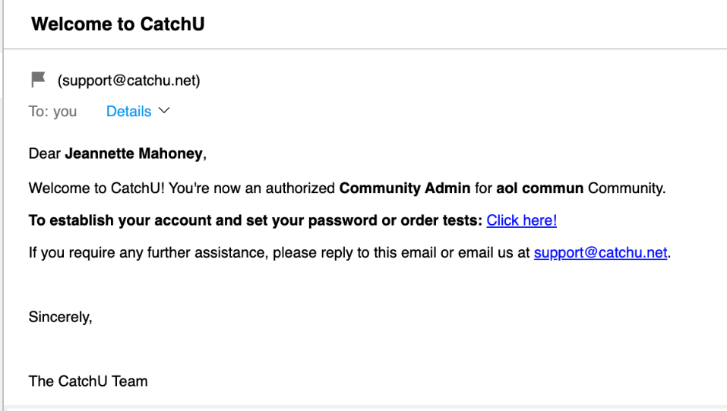
In the email, click where it says: “To establish your account and set your password or order tests, click here!” You will be directed to the CatchU portal and asked to create a password:

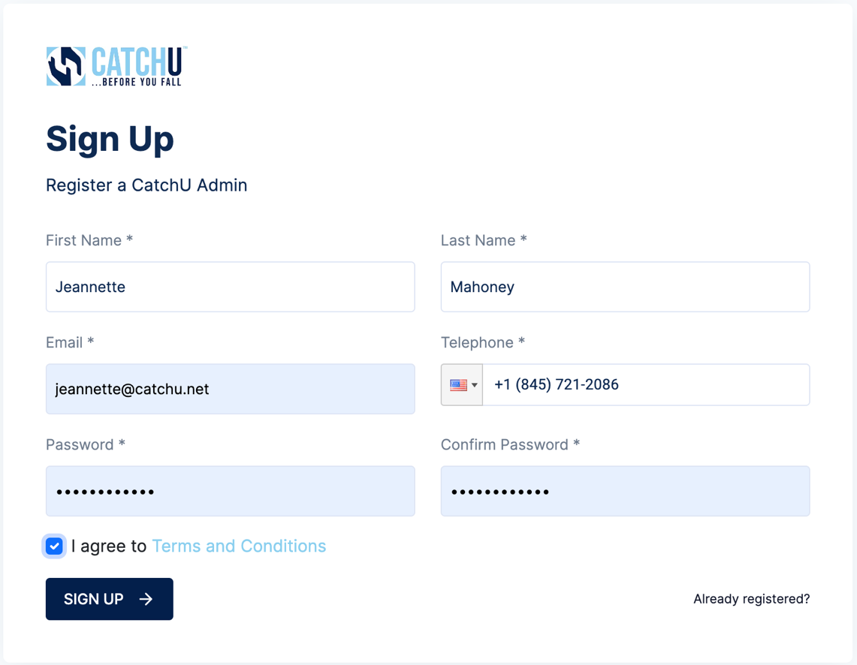

Once successfully signed up, you will be routed back to the login page, where you can input your registered email and recently created password, to login to the portal.

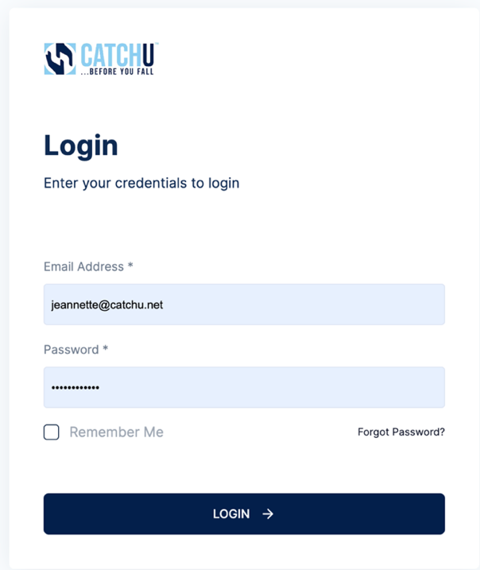

After the login is successful, you will be asked to check your email for a 6-digit one-time-password (OTP; highlighted in yellow below) which is an added layer of security for your account.

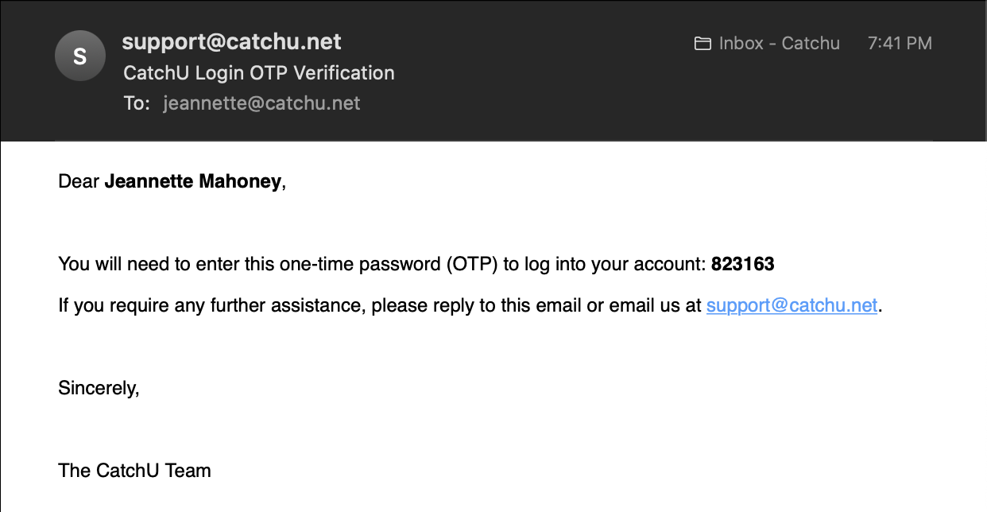

Please copy this 6-digit OTP from your email into the proper field (see highlighted OTP) below click the confirm button:

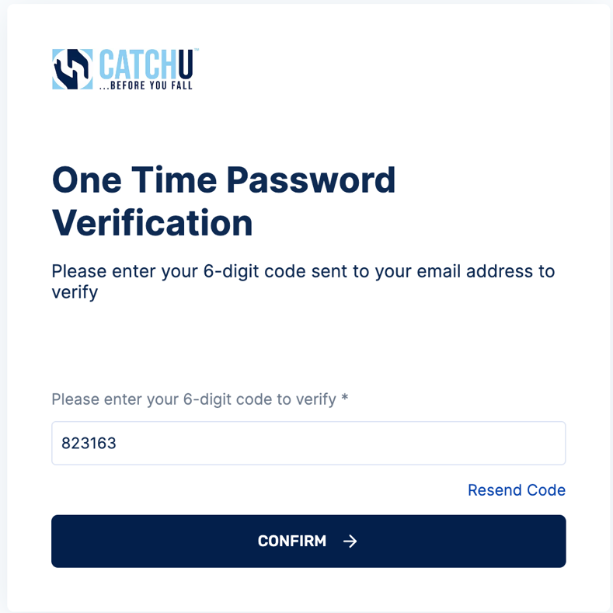

Then you will have access to the portal as depicted below:
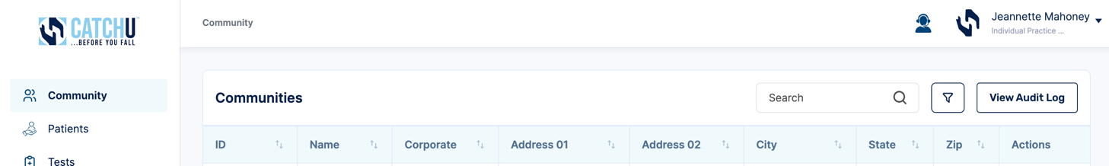

Once logged in, many functions can be performed depending on your role, but in general, these include:

- Update My Profile Information (name, phone #, email, etc.)

To access and edit a profile, click the located after the account name on the top right corner of the portal (see red arrow) which will open a pop-up menu where you can click and select “My Profile” (see red rectangle).

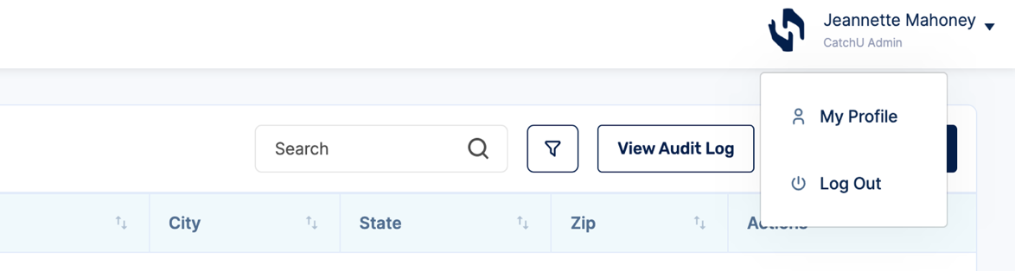

Once clicked, a new window will open (screenshot below) and each specific field can be filled in or revised.

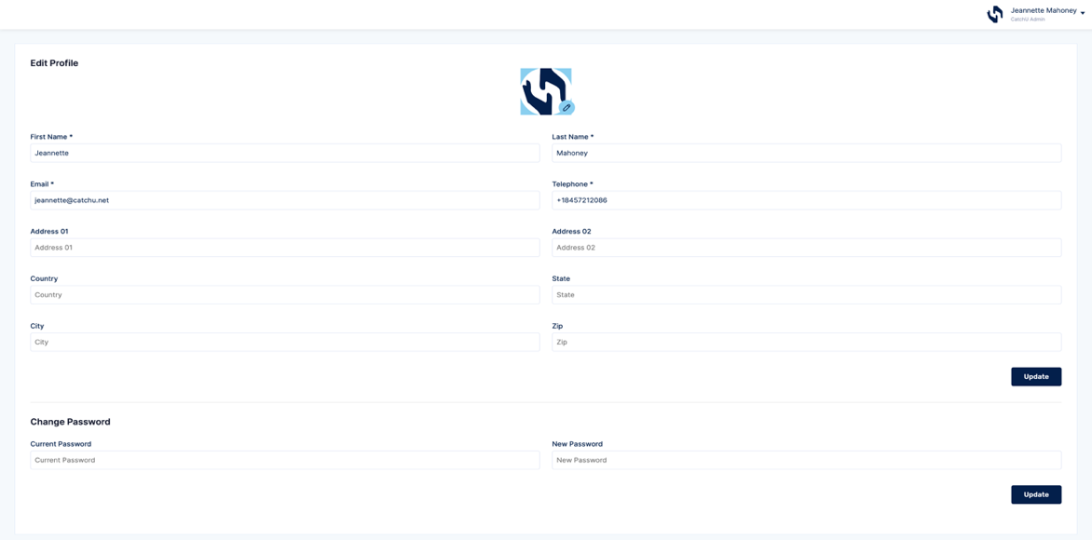

A profile picture can be added (completely optional) by clicking on the Pencil icon (circled in orange above). If you click here, you will need to specify the location in the pop-up window (see below) and select the file that you would like to upload and then click the “open” button.

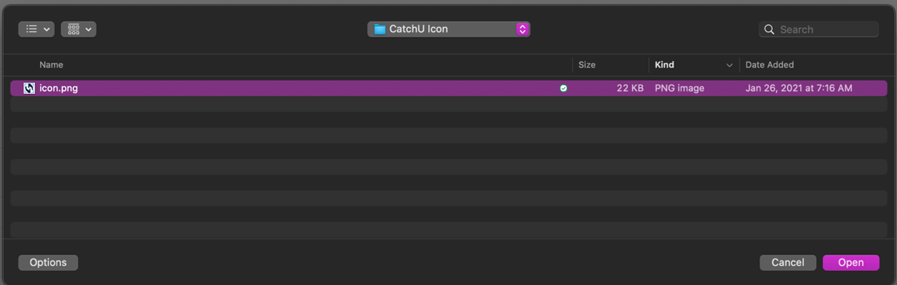

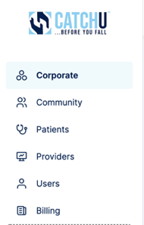
Once done with revising the My Profile information, please click the update button (see red box above) to save all changes. If you would like to change your password, you can do so in this My Profile window by entering both your current password and a new password and clicking the update button (see blue box above).

Then, click anywhere on the left toolbar to exit My Profile (red arrow).

- Manage (Add, Edit, & View) Communities

To access the Community section you will need to select “Community” located on the left side toolbar of the portal (see blue arrow below). Once the Community tab is selected, the following functions can be performed:

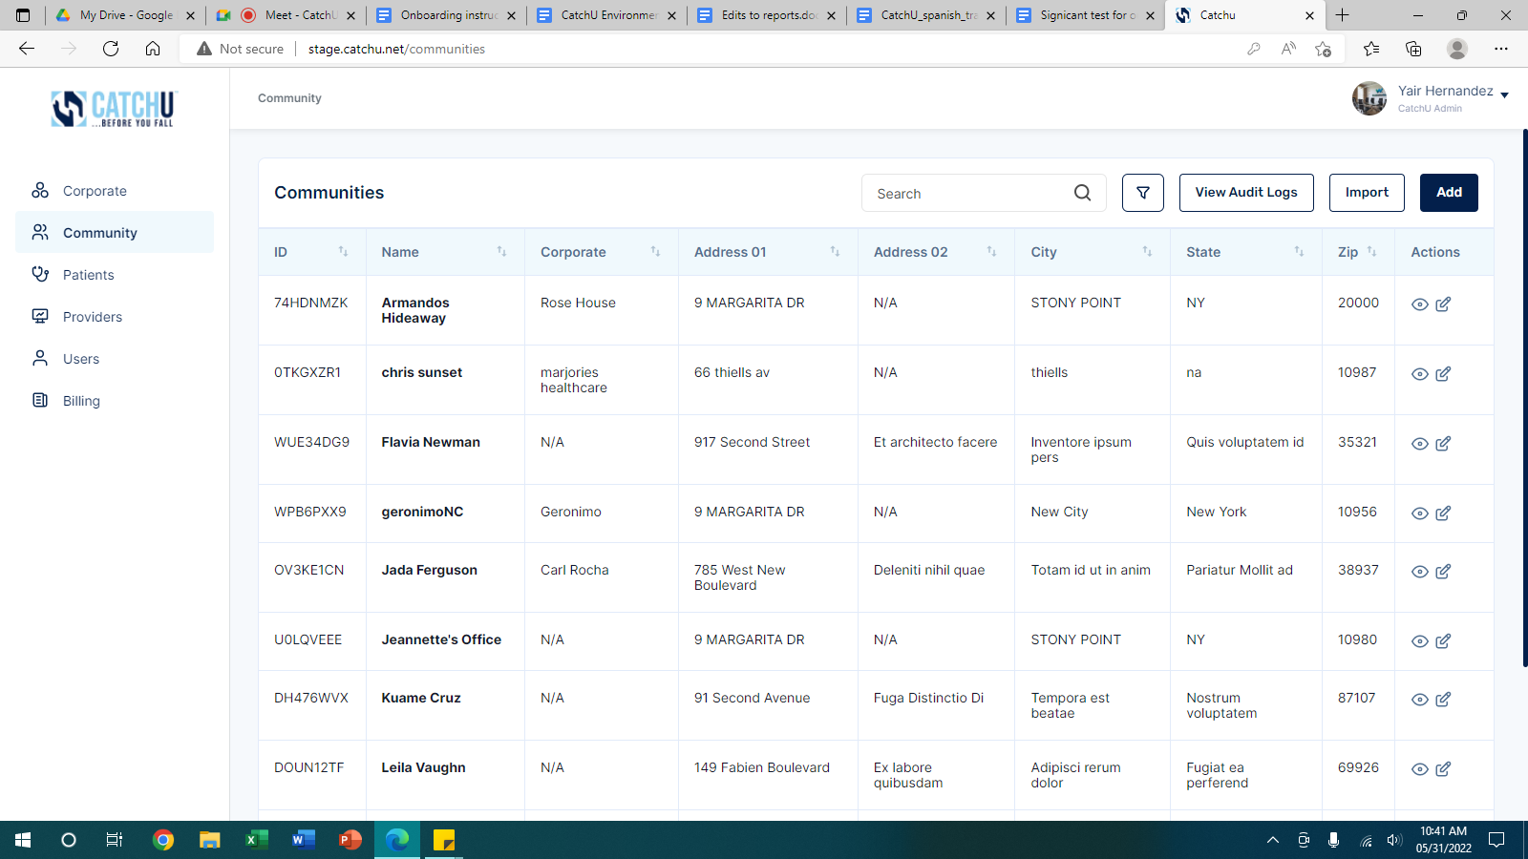
  - Manually add one Community at a time

Returning customers that have already accepted CatchU Terms & Conditions, can add new communities manually (one site at a time) in the portal by clicking the “Add” button (see red box below) and filling in the necessary fields. NOTE: all data presented in portal screenshots are made up and just meant to provide direction/examples for this User Manual. This data will not exist in the individual patient portals that you setup.

After you click “Add” (red box above), a new pop-up window will appear (next screenshot) and the following information will be required to add a new community and assign one person an administrator role to manage that specific community – don’t worry, other administrators can be added later, after the community is established in the CatchU portal.
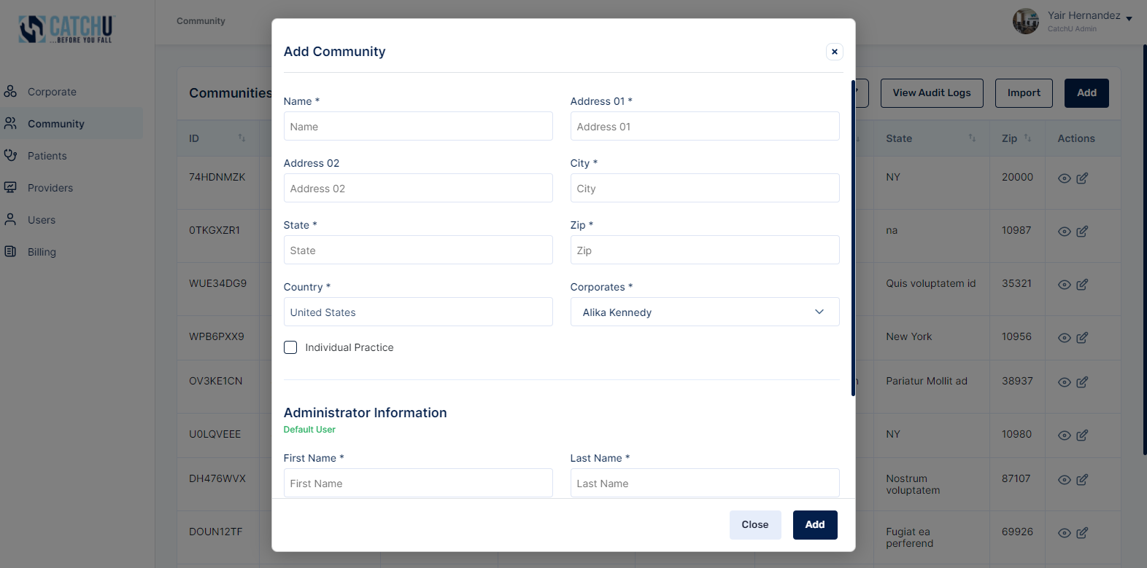

Be sure to click “Add” to save new corporate account details (see blue box above).
First time/new customers without portal access can register Practices or Communities (both are called “communities”) through our website at https://www.catchu.net/register (see orange ellipse below).

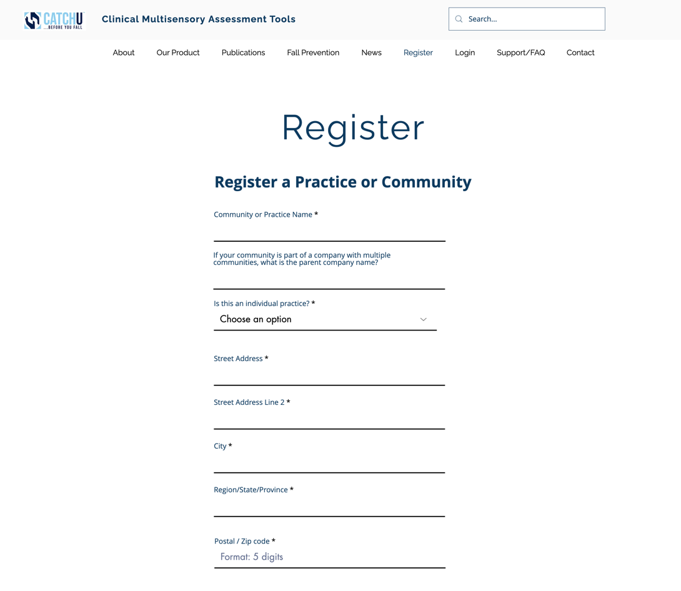

  - Import multiple Communities concurrently

After your practice or community is registered and you are able to login to the portal, you can import multiple communities by clicking “Import” (see red box above). A new pop-up window will appear, and the below information will be required to add several communities at a time. If communities are part of a Corporate location (see page 32 below), then they can be linked to a specific Corporate location by mapping the Corporate name to this variable (see blue arrow), but in the case where a Corporate location is specified, the only Role (see green arrow) that can be assigned through an import is “Community Admin.” When no corporate is assigned, then Role (see green arrow) should be “ Individual Practice Admin.”

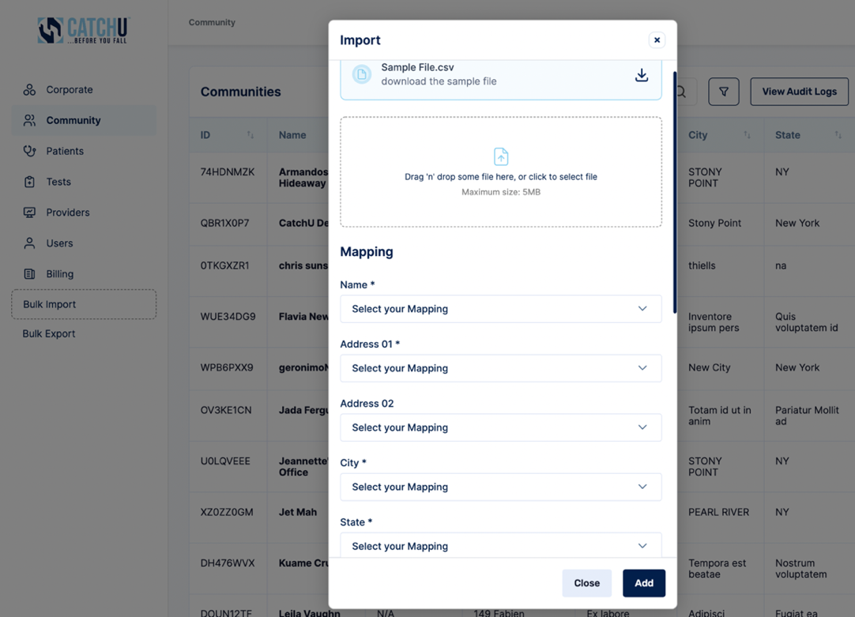

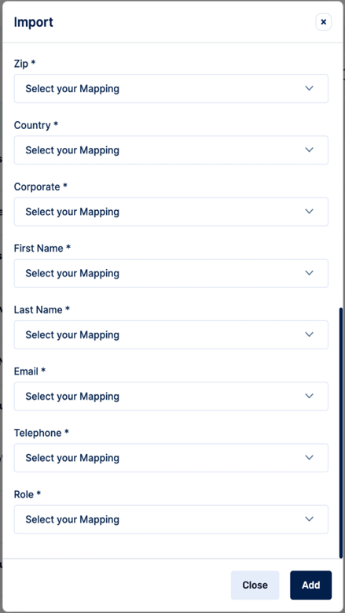

There are two options for importing multiple Communities at one time - these include:

    - You can download our sample .csv file (see purple box above), fill-in all of the columns with the required information to import many communities, and then drag ‘n drop the file (see green box above) and then click “Add” button (see red box above):

    - Alternatively, you can use an existing .csv file (if it contains the necessary information needed to import many corporate locations in the correct format*- see Note below). Simply drag ‘n drop the file in green box above (or click to select the file from your computer) and then click Add button (see red box above). However, after this existing file is selected and loaded here, you will be required to map the necessary information from this file to our required fields by selecting a mapping for each of the above listed variables

Note: When importing, there may be a case where one or multiple rows of data contain data that does not pass our initial data screen. If this occurs, then problematic rows will be copied to a new .csv file named “import-errors.csv”. Only failed rows will be copied and pasted into this new .csv file. All successfully imported data rows will be saved to the database. The new import-errors.csv file will inform the community administrator of the community locations (data rows) that failed to be imported. “Failure” to import may be due to incomplete or improperly formatted data that requires revisions. This could be due to formatting issues; please ensure that phone numbers are listed as 10-digit numbers without spaces, dashes, or country codes (e.g., 8457212086) and that the role is equal to “Community Admin" or “Individual Practice Admin". After the new .csv file is received via email, the Administrator will have the chance to revise data in the failed rows of the new auto-generated import-errors.csv file and then it can be uploaded to the portal using the same mapping process. Then, the portal will scan the import-errors.csv file and import successful rows and generate another import-errors.csv file if additional corporate information still contains errors. This process will continue until all data rows are successfully imported into the portal (basically, when no more error files are created).

  - Update/Edit Community or Practice information:

To update specific community information fields, first you will need to search for the community of interest and then press the Edit icon (see red box below). For example, if you want to edit the community entitled “Armandos Hideaway.” You would first find Armandos Hideaway on the list of communities (or search for it by name in the yellow search box pictured below) and then you would click the Edit icon located under the “Actions” column of the Community matrix in the specific community row that you want to edit (see red box).

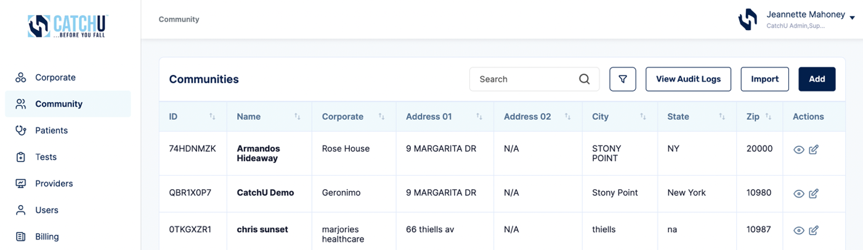

Once the Edit icon is clicked, a pop-up window will appear that will show community information previously inserted, and allow for it to be revised/updated. For example, zip code can be changed from 20000 (above blue box) to 10980 (below blue box). Note, please remember to click the “Update” button (see red box below) so that all changes will be saved.

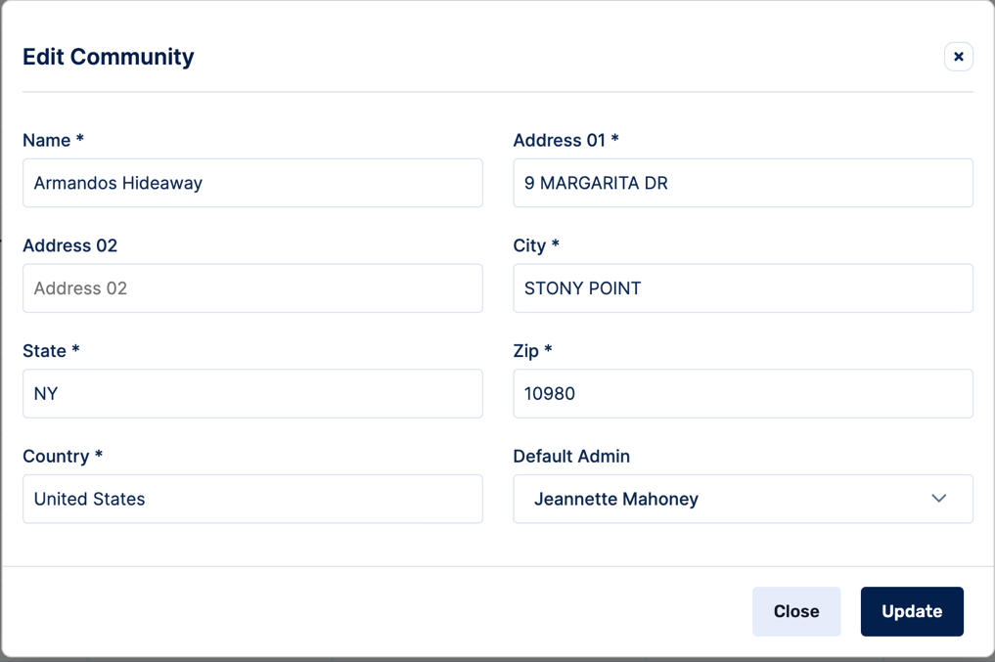

  - View Community Information

In order to view specific community information, you will first need to identify the community that you are looking to view. For example, find Armandos Hideaway on the list (you can also search for it by name in the yellow search box & hit enter) and then click the View icon located in the “Actions” column of the Community matrix in the specific corporate row that you want to view (see red box below).

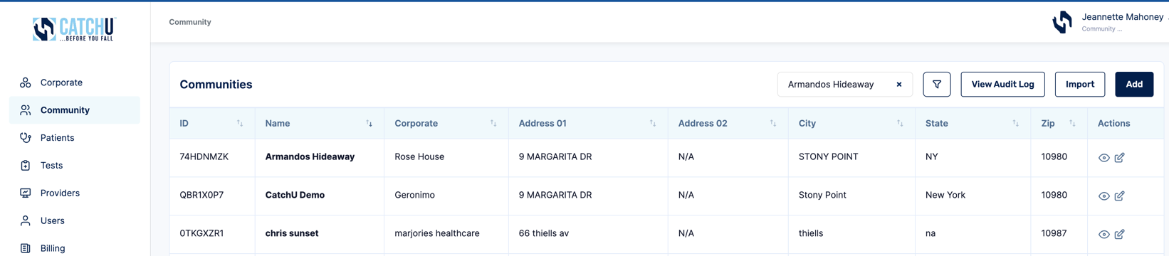
Once the View icon is clicked (red box above), a new pop-up window (screenshot below) will appear that will show various information for any given community. In this example, we are still looking at the community named Armandos Hideaway (black box above and below).

You will notice an Edit button (see purple box below) and a Create Group Test button (see gray box below). As well in pink box below, you will see tabs for: Patients, Users, iPhone or Android lists, Billees, Providers, and Group Test History associated with a given community. Each tab will have a cyan line under it when its clicked (see Patients is underlined below) to indicate which tab is currently active. This is also clear by the title name above the data matrix “Patients” (see cyan box).

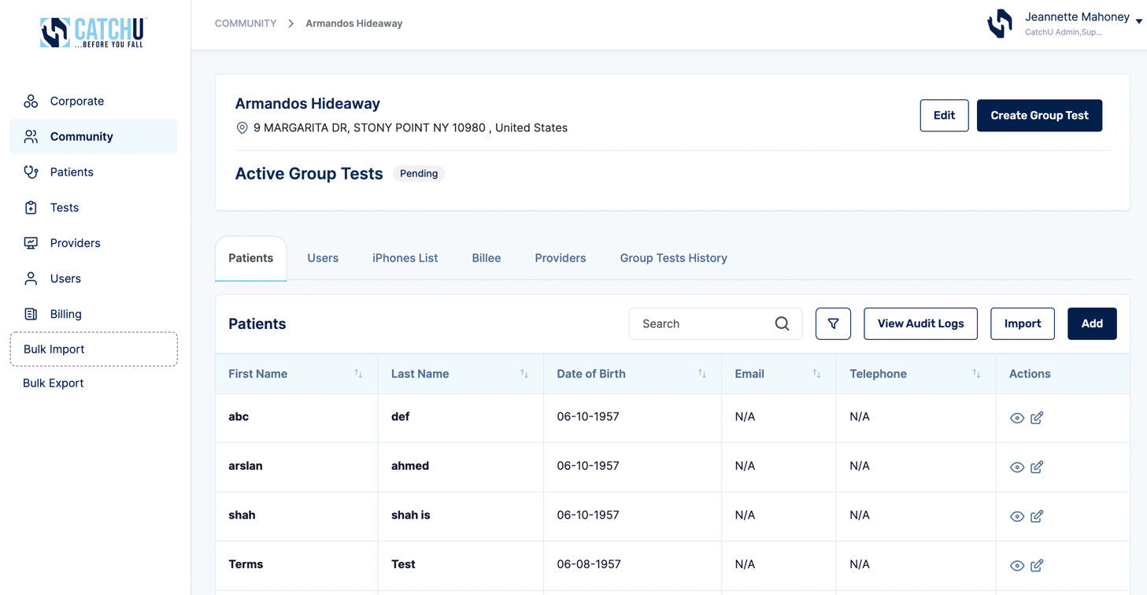

If you click Edit (purple box above), it brings up a new pop-up window that allows you to edit community information, as discussed above on pages 12-13 under c) Update/Edit Community or Practice information:

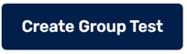
If you click on (see gray box above), you will be creating a new group test for a given community. Group Tests allow communities to have many patients take a CatchU test on the same or different iPhones or Androids. This feature is especially handy in Assisted Living Communities where a nurse may want to go room to room to test multiple patients in one day. We will get back to this feature again when we get to 5) Ordering Tests starting on page 40. Group Tests can only be setup under this function when at least one Provider and one Billee is assigned to a community. We will review this now, in what follows.

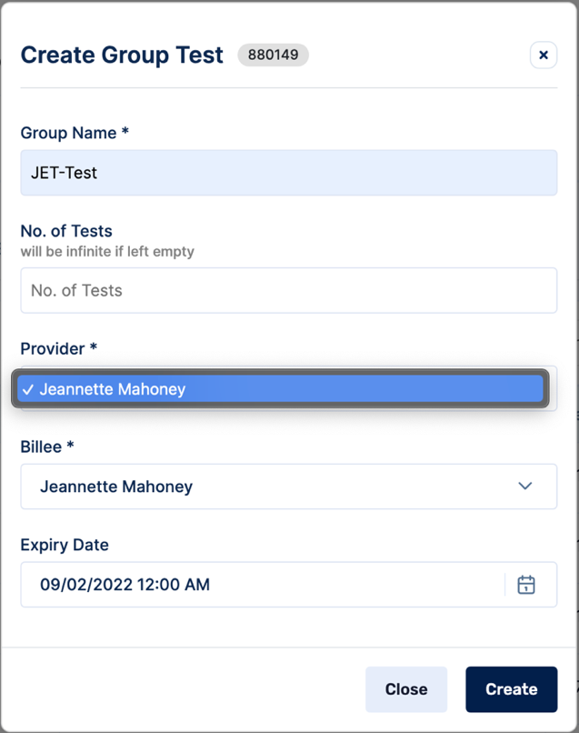

---------------------------------------------------------------------------------------------------------------------------------

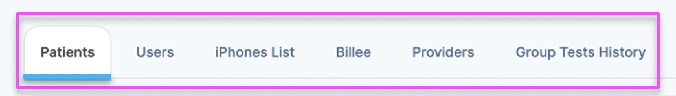

Tabs:

- Patients Tab

When it comes to patient information, it is critical that we only store minimal identifying patient information on our encrypted Amazon Web Services (AWS) Server. This data is only collected since it is necessary to order tests, include on confidential patient reports to the provider, and use to determine future age-based normative data.

As far as functionality goes under the Patients tab, here you can add patients (see yellow box above) and import patients (see green box above) in the same manner as previously outlined for manually adding corporates & communities or for importing many corporates & communities detailed in page 12 of this manual. You will also notice there is a View Audit Log button (see orange box above). This functionality exists for most tabs and we will cover this in greater detail under 4) Audit Logs (see page 39).

Necessary patient information stored in our database under the Patients tab includes:

- Patient First & Last Name
- Date of Birth
- Email Address
- Telephone Number
Here is an example of the pop-up window that is generated when you click Add patient (yellow box above):
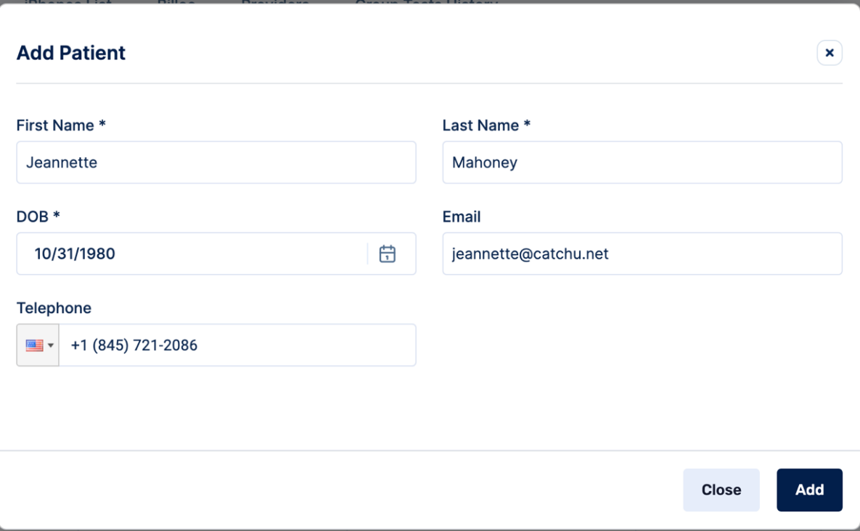

Note that when adding patients’ information manually, there is a calendar picker (featured below) for date of birth (DOB). It is easiest if you select month first, then year (which can be typed in), and then select the date (here 31 is selected as the date). Once 31 is clicked, the DOB* field will populate as 10/31/1980 (as in above screenshot).

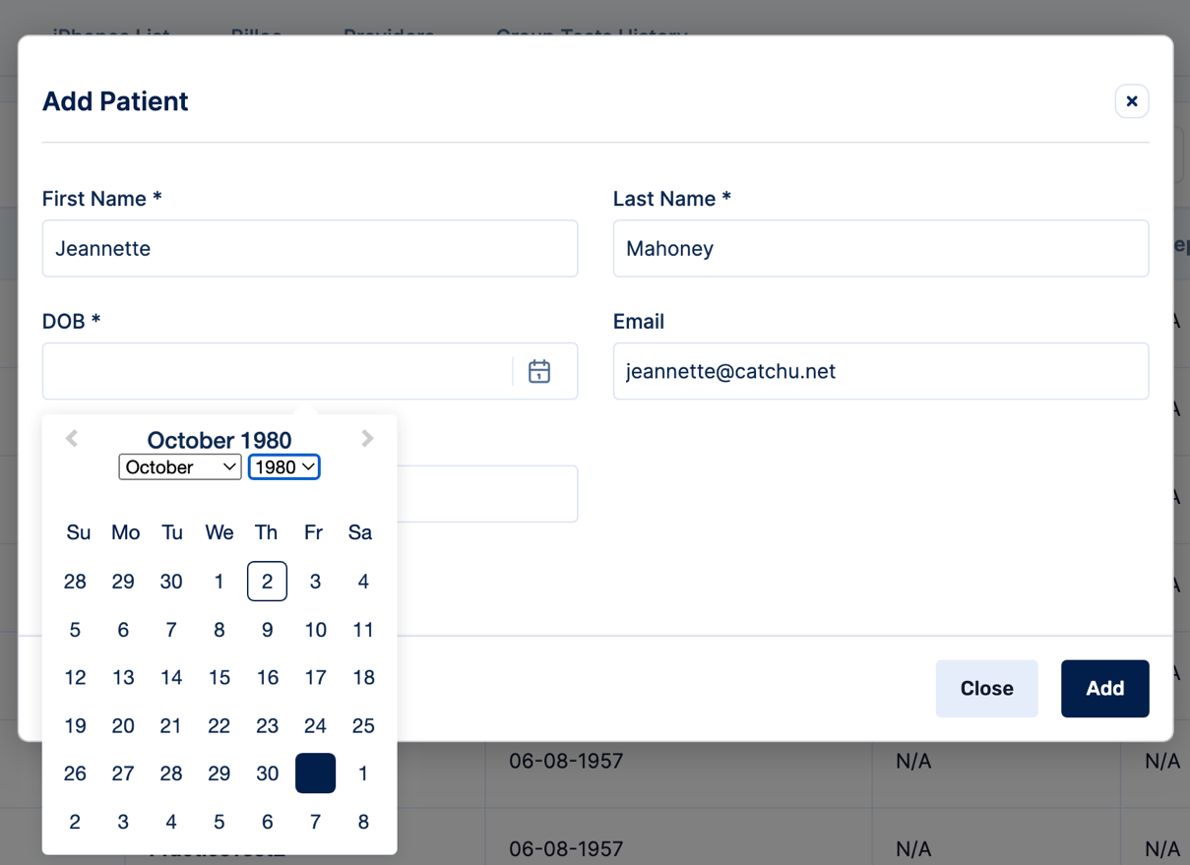

Be sure to fill in the above required fields and then click “Add” to save patient details (see red box above).

Patient Option on Left Side Toolbar

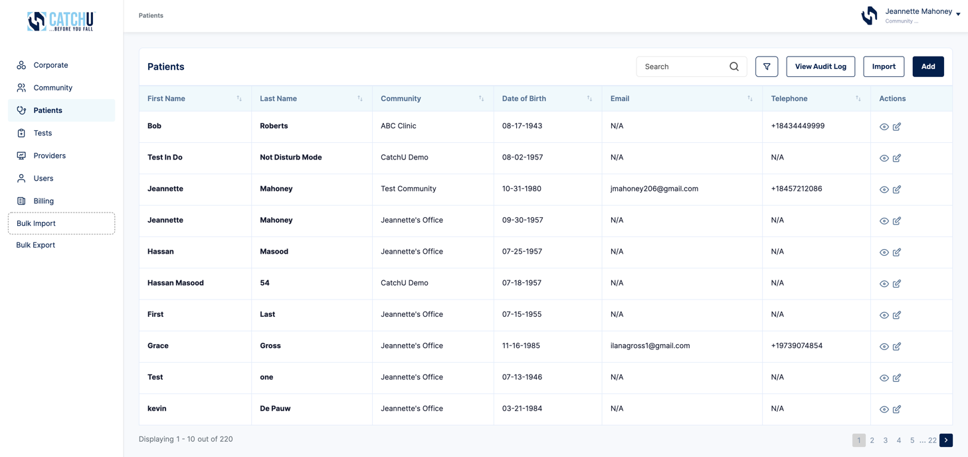

Selecting Patients on the left side toolbar (blue arrow) will allow you to see all of the patients associated with particular communities. If as a CatchU Admin you have access to more than one community, you will be able to see multiple patients across multiple communities that you have access to. Once the Patients left side toolbar is selected, additional Patients can be added or imported - add patients (see yellow box above) and import patients (see green box above) in the same manner as previously outlined for manually adding corporates & communities or for importing many corporates & communities detailed in page 12 of this manual.

- Users Tab

Users for a given community can have a defined Role as either a “Community Admin” or “Support Staff.” Each type of user has different permission levels. For your reference, here is the Permission Matrix for the CatchU portal.

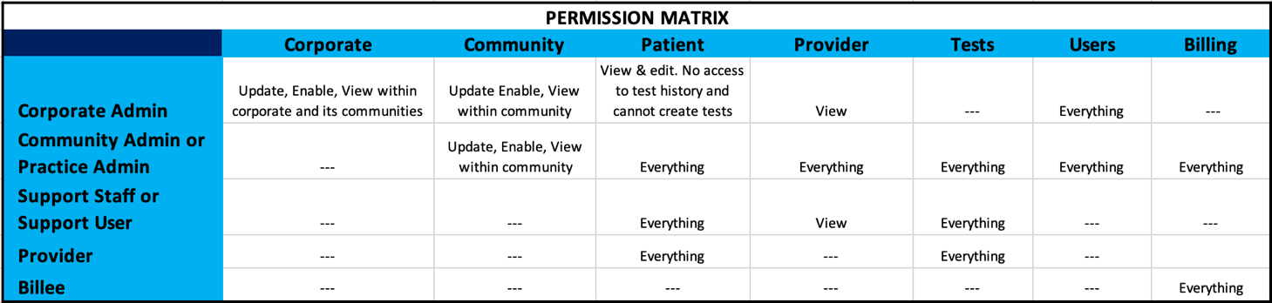

Based on above permissions, each community can decide which users they want to have access to above-listed functionalities and select whether the user is to have “Community Admin” or “Support Staff” privileges (highlighted in yellow above).

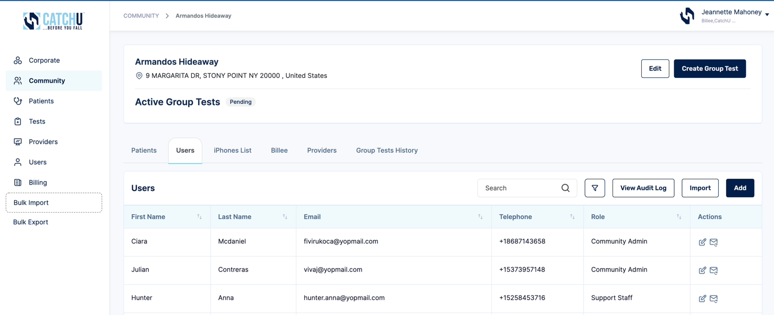

As far as functionality goes under the Users tab, here you can Add users (see yellow box above) and import users (see green box above) in the same manner as previously outlined for manually adding corporates & communities or for importing many corporates & communities detailed in page 12 of this manual.

Necessary User information for the User tab includes:

- First & Last Name
- Email Address
- Telephone Number
- Role (either a “Community Admin” or “Support Staff”)

Here is an example of the pop-up window that is generated when you click Add User (yellow box above):
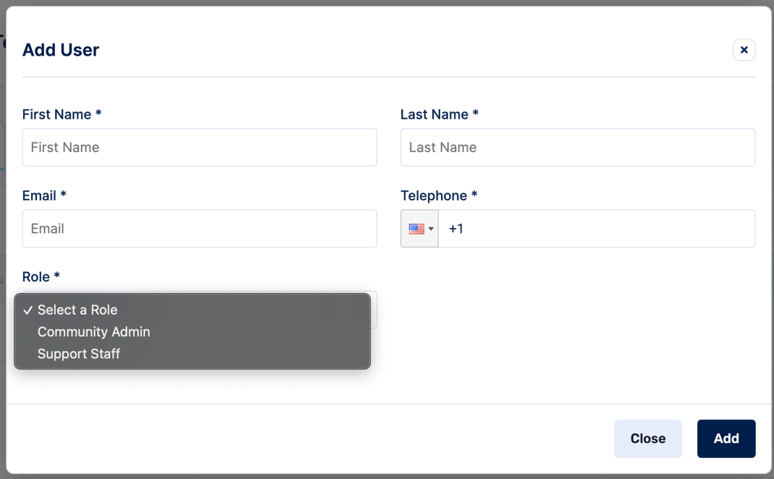

Be sure to fill in the above required fields and then click “Add” to save User details (see red box above).

You will notice an Edit option (pink box above) and a Resend email (see orange box above).
If you click the Edit option (pink box), you can edit existing User information, but be sure to click “Update” to save revised User information (red box). As well, you will notice that from this tab you can also “Add” more roles to specific users (cyan box).

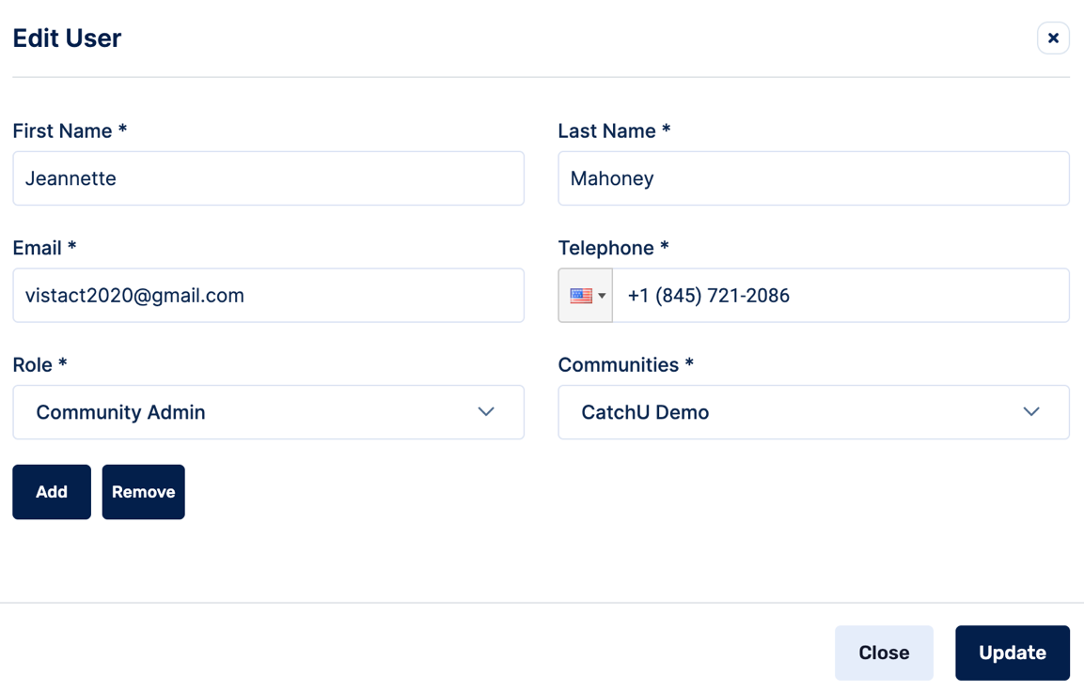

When you click “Add” (cyan box), additional roles can be granted to existing users. In this case, Jeannette is already listed as a Community admin (purple box above and below), but from the pull-down menu, Jeannette can also be assigned other roles including: Corporate HQ Admin (if the community is linked to a corporate account), Individual Practice Admin, or Support Staff. You can keep selecting Add and additional Role boxes will appear. If you add too many Roles*, simply click the “remove” box (light green box below). Note, here you can only remove new Roles that were just added (not the original registered User Role).

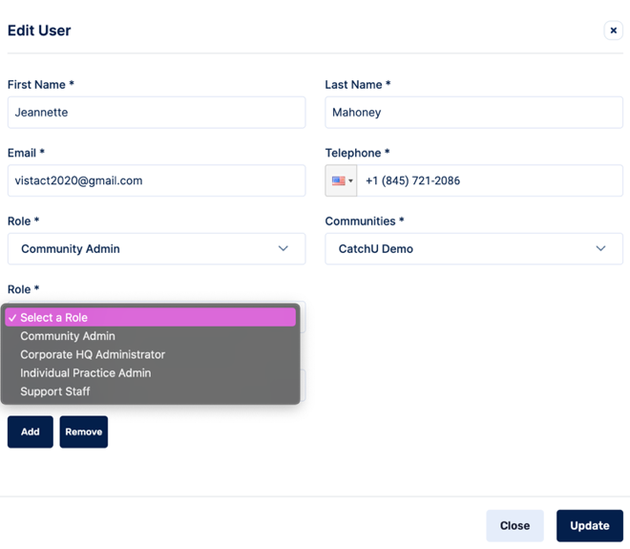

Be sure to click “Update” to save any User changes (see red box above).
If you click the Resend email (orange box), the below message will pop-up. Please confirm whether you want to Resend the user an email

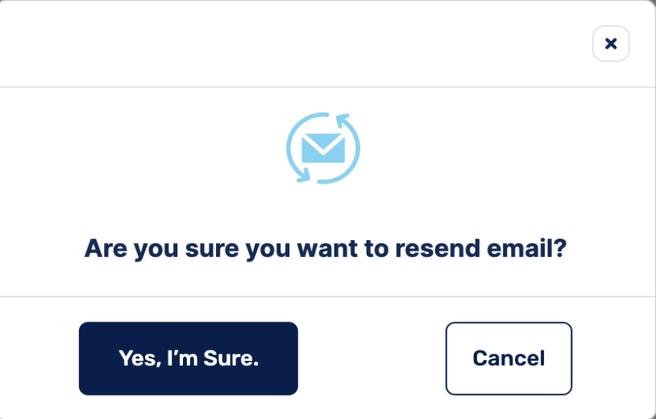

If you click “Yes, I’m sure” then the user will receive the following email from support@catchu.net allowing the User to reset their password in order to be able to log back in to the CatchU portal.

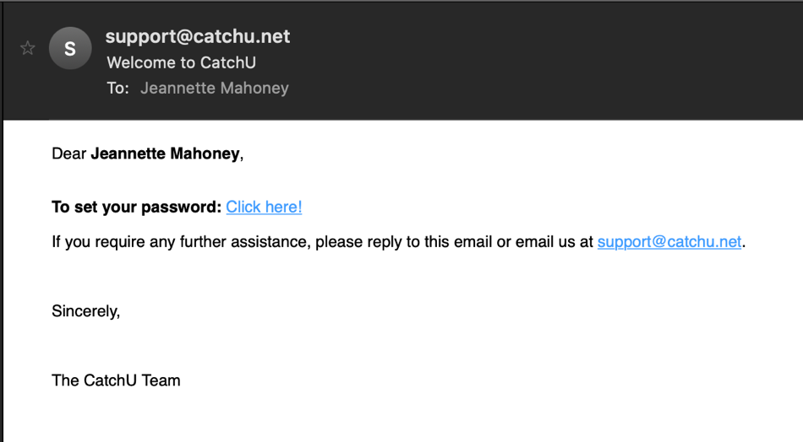

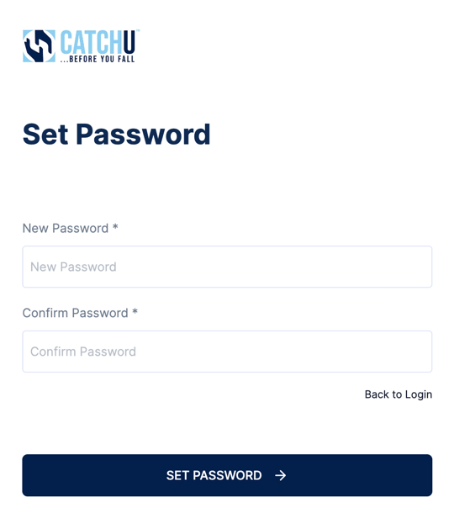

Users Option on Left Side Toolbar

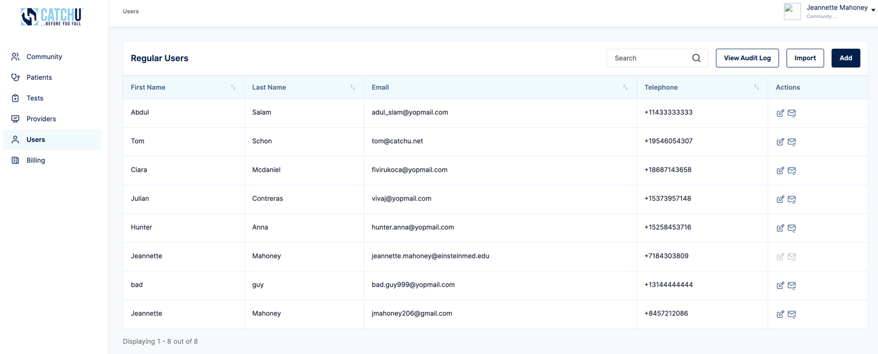

Selecting Users on the left side toolbar (blue arrow) will allow you to see all users associated with a particular community. If as a Community Admin you have access to more than one community, you will be able to see multiple patients across multiple communities that you have access to. Once the Patients left side toolbar is selected, additional Patients can be added or imported add patients (see yellow box above) and import patients (see green box above) in the same manner as previously outlined for manually adding corporates & communities or for importing many corporates & communities detailed in page 12 of this manual.

- iPhones List Tab

Under the iPhone tab, you have the ability to register house iPhones that will “live” in the office, practice or community. These iPhones must be version 7 or higher to support CatchU test functionality and the CatchU app. They do not require a cellular plan but must be connected to the office’s WiFi to ensure proper data transfer.

As far as functionality goes under the iPhone tab, here you can add iPhones (see yellow box above) and import iPhones (see green box above) in the same manner as previously outlined for manually adding corporates & communities or for importing many corporates & communities detailed in page 12 of this manual.

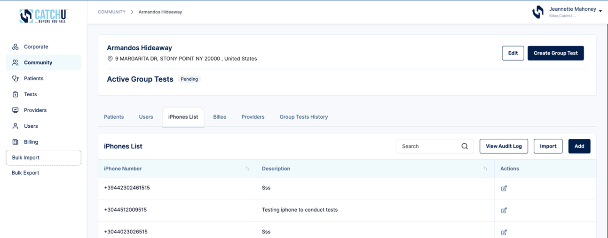

Here is an example of the pop-up window that is generated when you click Add iPhone (yellow box above):
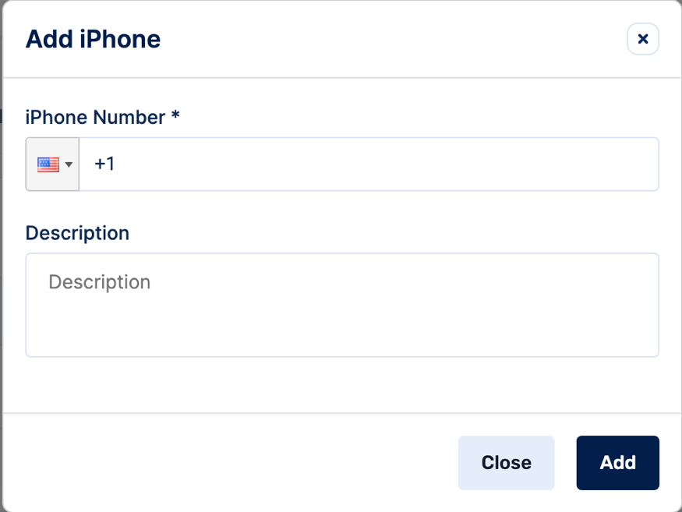

Be sure to fill in the above required fields and then click “Add” to save User details (see red box above). The Description box is optional and can be used when multiple house iPhones or Androids are registered – though we recommend that you label each iPhone or Android before adding it to the Portal so that the proper name can be added to the description box above.

- Billee Tab

Some communities may use outside billing services while others may assign in-house Billers to monitor associated test billings. We provide flexibility in so far as we allow each community to designate one or many billers that will be charged with monitoring associated CatchU services. However, and as mentioned above, before tests can be ordered, at least one Billee needs to be added per community (even if the same person is also a Community Admin or Support Staff).

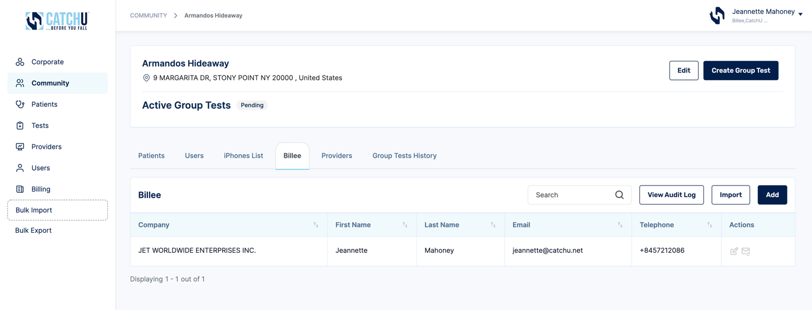

As far as functionality goes under the Billee tab, here you can add Billees (see yellow box above) and import Billees (see green box above) in the same manner as previously outlined for manually adding corporates & communities or for importing many corporates & communities detailed in page 12 of this manual.

Here is an example of the pop-up window that is generated when you click Add Billee (yellow box above):
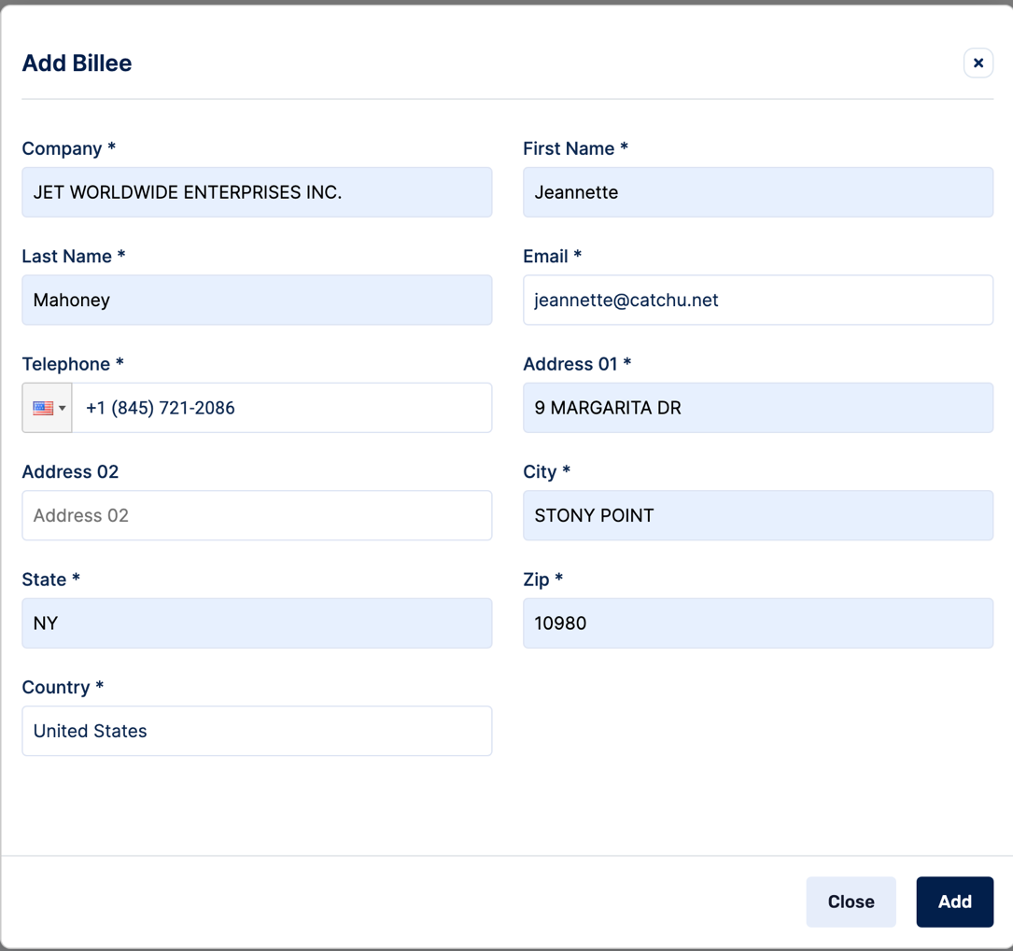

Be sure to fill in the above required fields and then click “Add” to save User details (see red box above).
- Providers

Each community must have at least one Provider associated to the account before tests can be ordered. The provider can be an MD, PA, NP or DO.

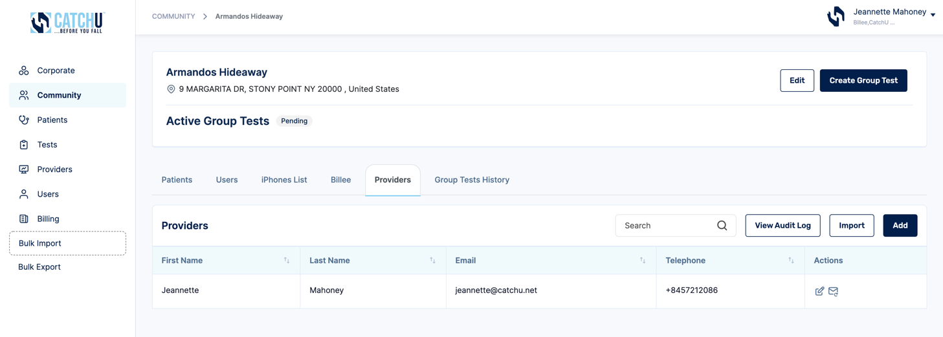

As far as functionality goes under the Provider tab, here you can add providers (see yellow box above) and import providers (see green box above) in the same manner as previously outlined for manually adding corporates & communities or for importing many corporates & communities detailed in page 12 of this manual.

On next page is an example of the pop-up window that is generated when you click Add Provider (yellow box above). You can see here that in the case where a specific Provider relies one specific Billee, that information can also be included here (not a required field). However, when a Provider registers his/her own Billee here, then only the Provider’s registered Billee will receive invoices related to patients’ tests these invoices will not go to the registered Community Billee listed in the Billee Tab (pages 23-24).

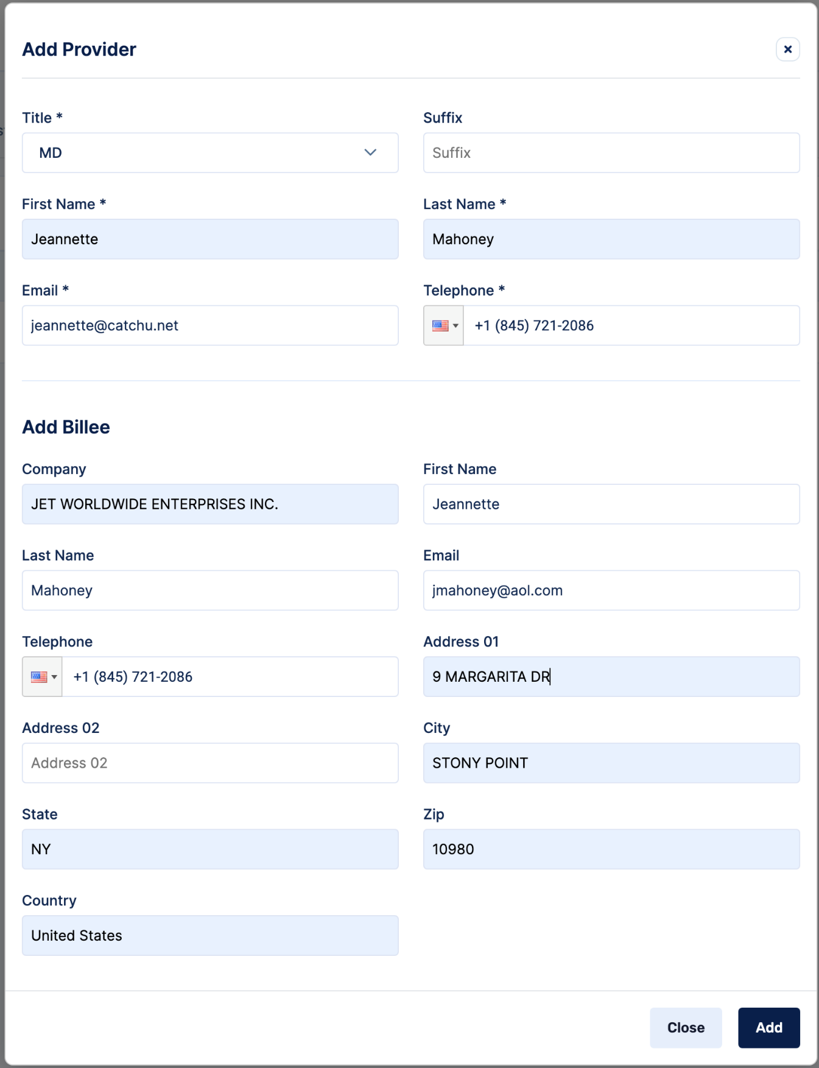

Be sure to fill in the above required fields and then click “Add” to save User details (see red box above).

Supplying an email address for each provider is essential because 3 days after a patient completes their CatchU test, the email address listed under the provider will receive a confidential patient test result report (sent as a .pdf attachment from reports@catchu.net) for all patients linked to that specific provider at the specific community.

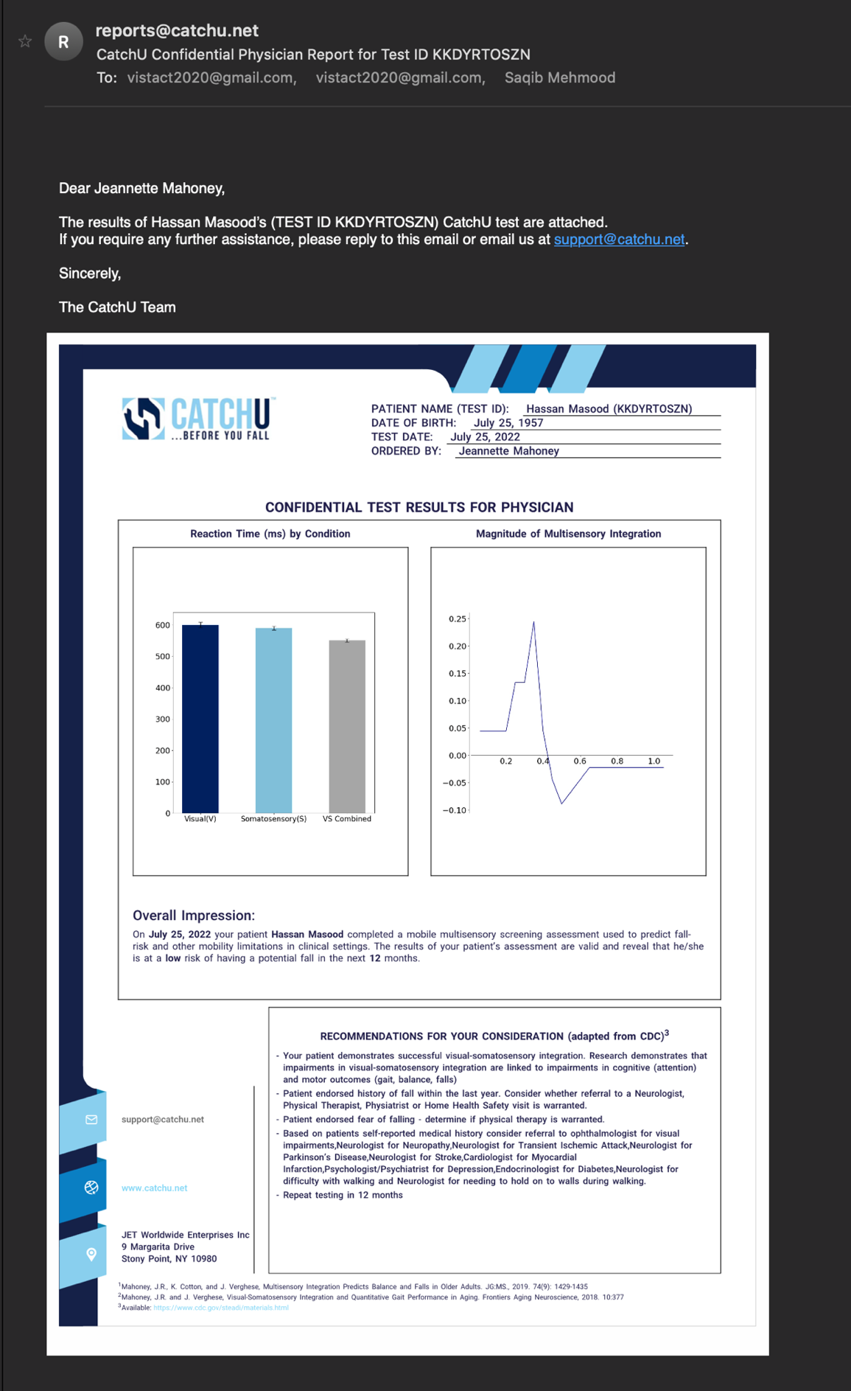

Provider Option on Left Side Toolbar

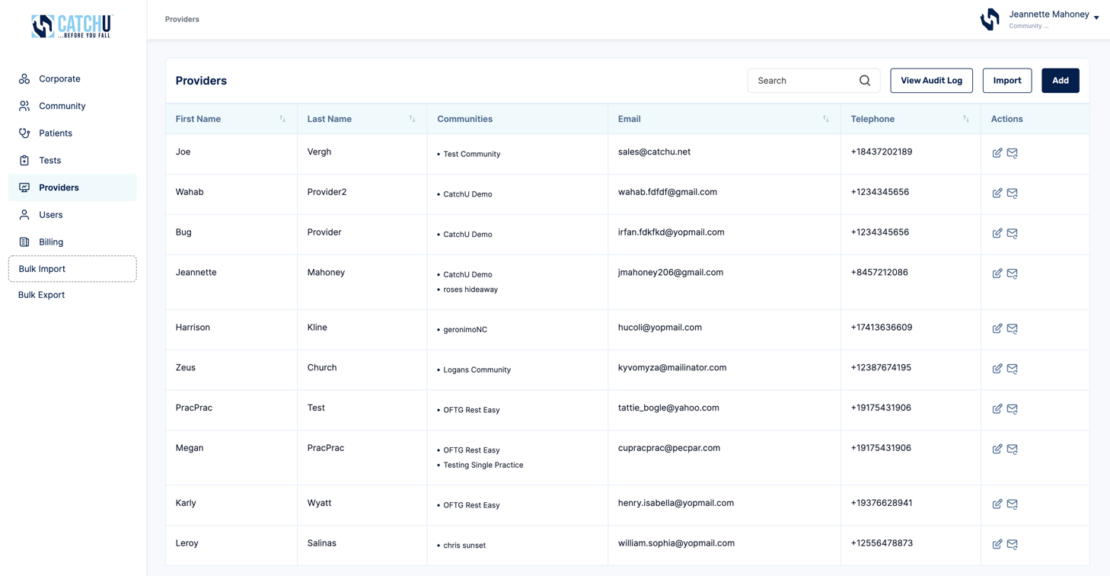
Selecting the Provider tab on the left side toolbar (blue arrow) will allow you to see all of the providers associated with a particular community. If as a CatchU Admin you have access to more than one community, you will be able to see multiple Providers across multiple communities. Once the Provider left side toolbar is selected, additional Providers can be added or imported - add Providers (see yellow box above) and import Providers (see green box above) in the same manner as previously outlined for manually adding corporates & communities or for importing many corporates & communities detailed in page 12 of this manual.

- Group Test History Tab

When you click Create Group Test (see gray box below), you will be creating a new group test for a given community. Group Tests allow communities to have many patients take a CatchU test on the same or different iPhones. This feature is especially handy in Assisted Living Communities where a nurse may want to go room to room to test multiple patients in one day.

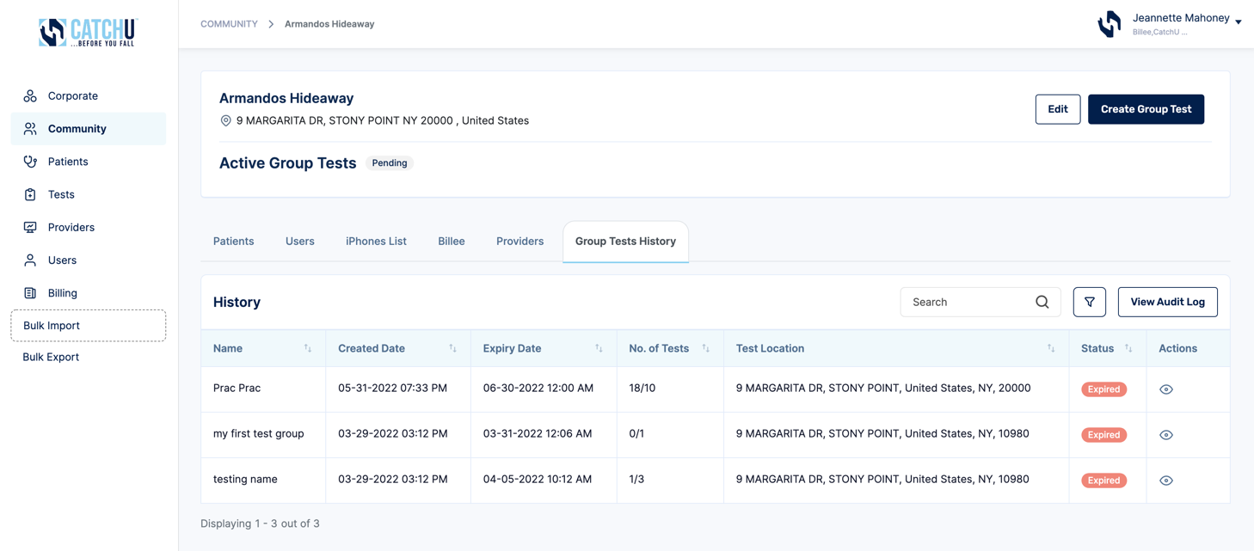

Prac Prac

Otherwise, the main data matrix on this tab serves to indicate all created group Names, when they were created, when they expire, the number of tests taken under this group test, the group test location and the group test status.
Under the Actions column, if you click the View (red box above), a new pop-up window (screenshot below) will appear that will show patient history of all the patients that received CatchU testing under a given group test name. In this example, we are still looking at a few patients that took CatchU under the Prac Prac group test (black box above and below).

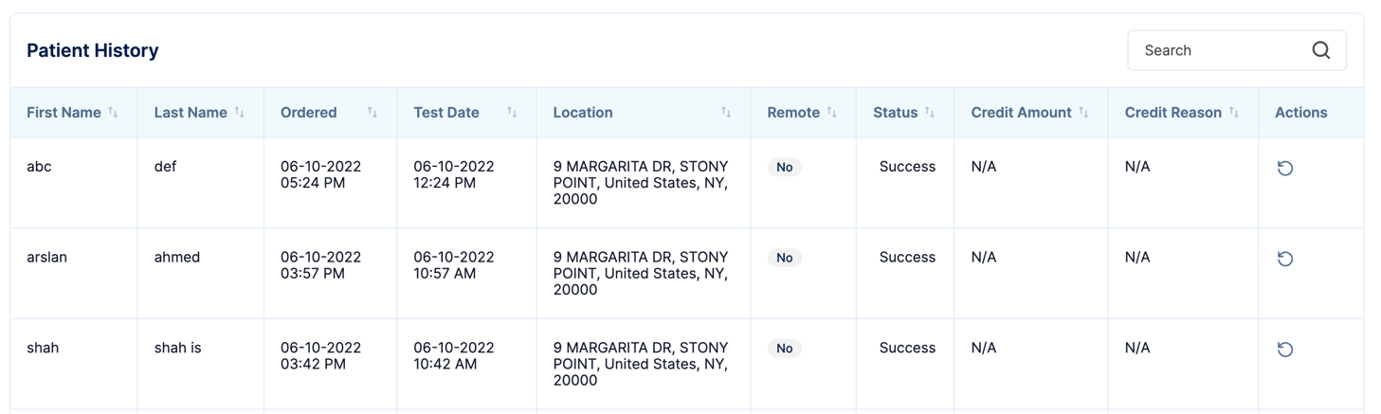

Within the patient history here, there is an opportunity to resend a report to a provider registered to the given community. If you click the circular arrow button (pink box above), a new pop-up window will come up and ask you which Provider you would like to resend the CatchU Report (i.e., results) to again. You can select one of the registered providers from the pull-down menu and click send (red box below).

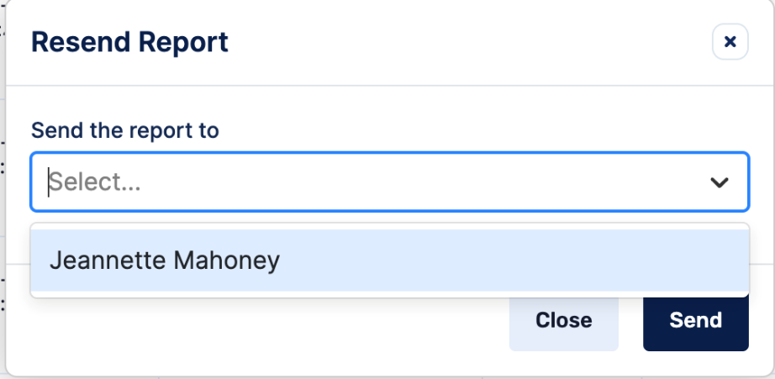

This will trigger an email to be sent to the provider with a copy of the confidential test results as a .pdf attachment. See below for an example email that a provider will receive which includes a sample confidential physician CatchU report.

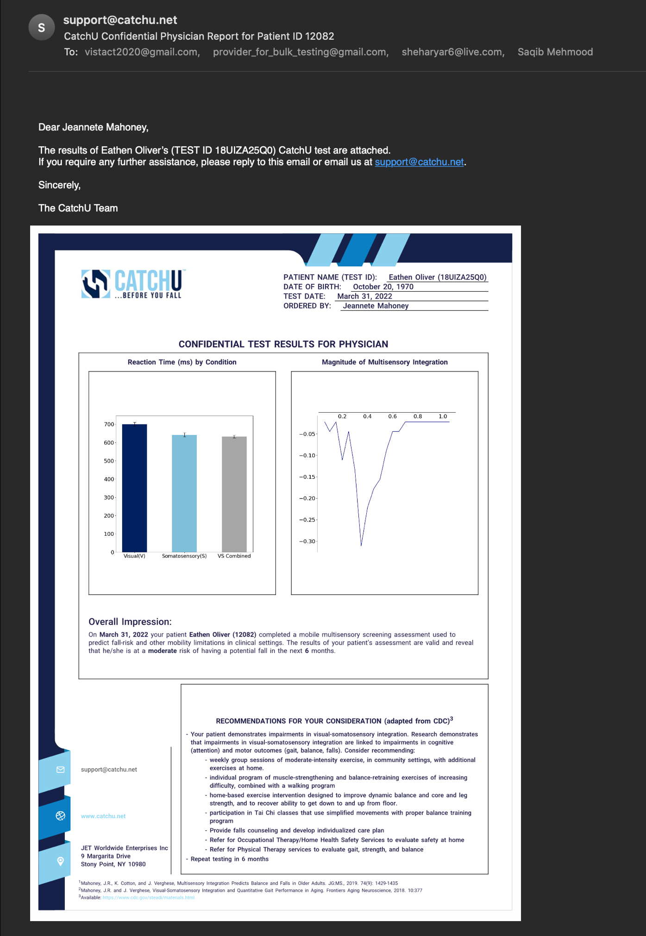
reports

- Manage (Add, Edit, & View) Corporate Accounts that are linked to Specific Communities (FOR CORPORATE HQ ADMINS ONLY if applicable)

Here you will need to select the “Corporate” tab located on the left side toolbar of the portal (see blue arrow). Note, if you are a practice or community, that is NOT connected to a larger Corporate account, you will not see the Corporate option on the left side toolbar and this section will not be applicable to you – feel free to skip to Audit Logs on page 39. Once the corporate tab is selected, the following functions can be performed:

  - Manually add one corporate account at a time

After you click “Add” (see red box above), a new pop-up window will appear (see next screenshot), and the following information will need to be filled out to add a new corporate account. Note, you must assign one person the role of a Corporate HQ Administrator to manage this account (and fill in their details) in order to successfully add this Corporate account. All mandatory fields are marked with an *.

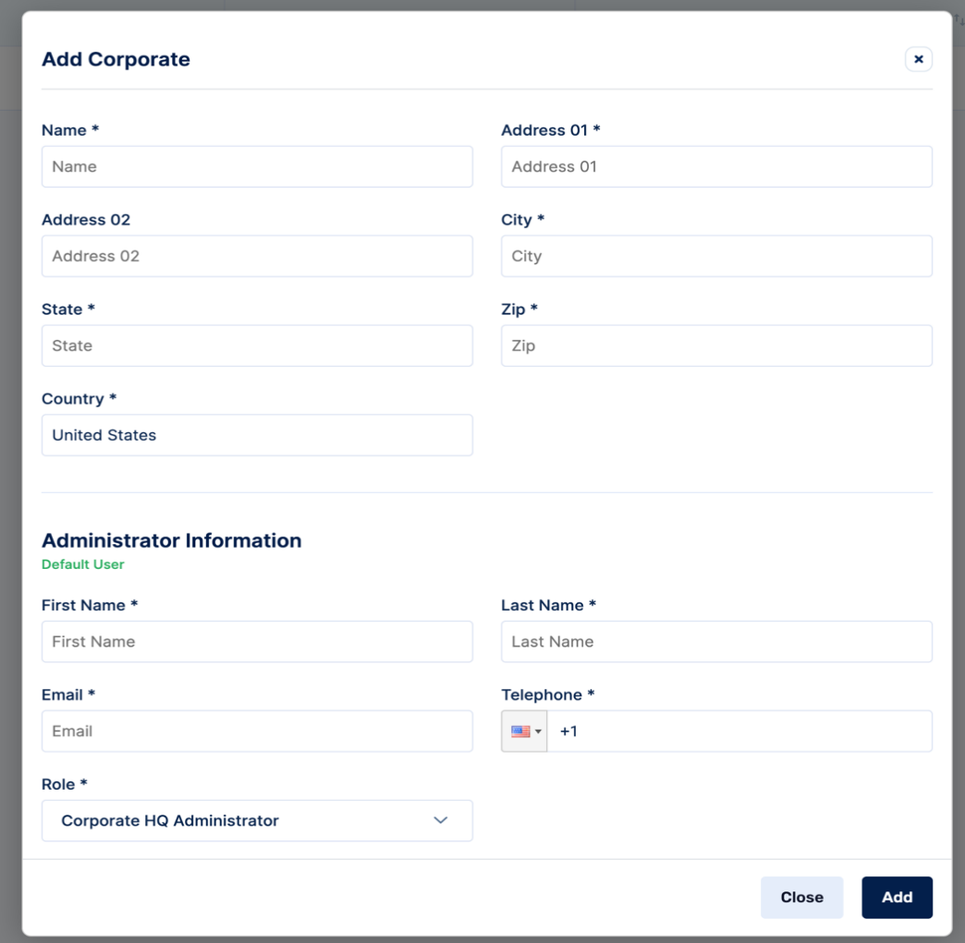

Be sure to click “Add” to save new corporate account details (see red box).

  - Import multiple community locations (that are part of the corporation) concurrently

If you want to add multiple corporate locations, click “Import” (see red box below) and this pop-up window will appear:

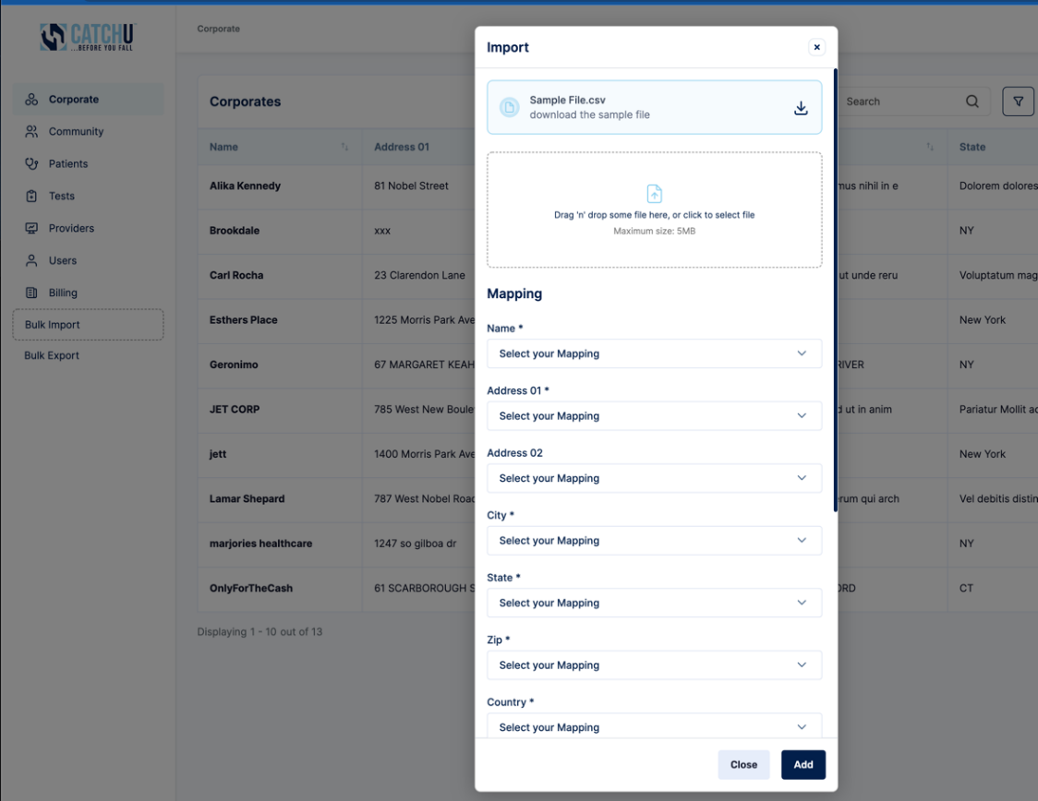

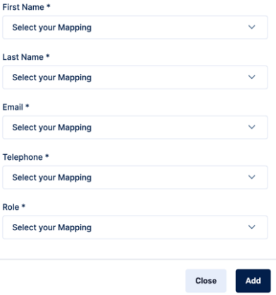

Within this pop-up menu there are two options for importing multiple corporate locations at one time. These include:

                - Import using CatchU .csv file template: You can download a sample .csv file (click inside purple box) from the portal. Open the .csv file and fill-in all of the columns with the required information (some column headers contain sample format information like phone number as 10 digit # - no dashes or spaces, just xxxxxxxxxx). When finished, please save .csv file and then drag ‘n drop the file into the portal in the drag ‘n drop area depicted in green box above. Then click “Add” button (orange box)

Note: The only Role (green arrow) that can be assigned through import is “Community HQ Administrator.”

                - Import using existing .csv file: Alternatively, you can use an existing .csv file (as long as it contains the necessary information needed to import multiple community locations (that are part of the corporation) in the correct format*- see page 12 for more details). Simply drag ‘n drop your existing .csv file in drag ‘n drop area depicted above in green (or click to select a .csv file from your computer, followed by the “open” button). Note, after your .csv file is selected and loaded into the portal (example below is “CatchU_corporate_test.csv”), you will be required to map the necessary fields from your .csv file to the required fields depicted in the above Mapping section (yellow box). Here, it is possible to indicate which variables (the column header names from your .csv file will be imported to generate a pull-down menu as in below Example, screenshot) will map onto our prespecified required fields for the above listed variables.

Example: Here, CatchU_corporate_test.csv file was dropped in the drag ‘n drop area. For Name * field, hit “select your mapping” and then choose which variable to map – here we will select “name” variable (highlighted in purple) from the CatchU_corporate_test.csv file. You will need to map all variables before hitting add.
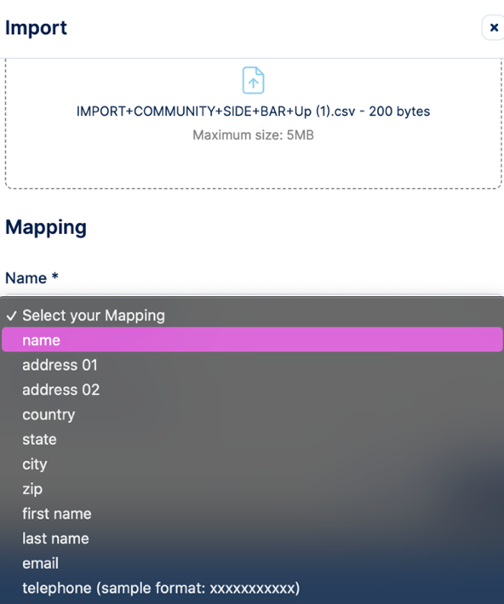
Catchu_corporate_test

  - Update/Edit corporate information:

To update specific corporate information fields, first you will need to find your registered corporation and then press the edit icon (see red box below). For example, say you were looking to edit the corporate account entitled “Geronimo.” You would find Geronimo and then click the edit icon located under the “Actions” column of the corporate matrix in the specific corporate row that you are editing (see red box). Despite below example, the most likely scenario involves a Community HQ Administrator only being linked to 1 corporate location, resulting in a list of only 1 Corporate location below.

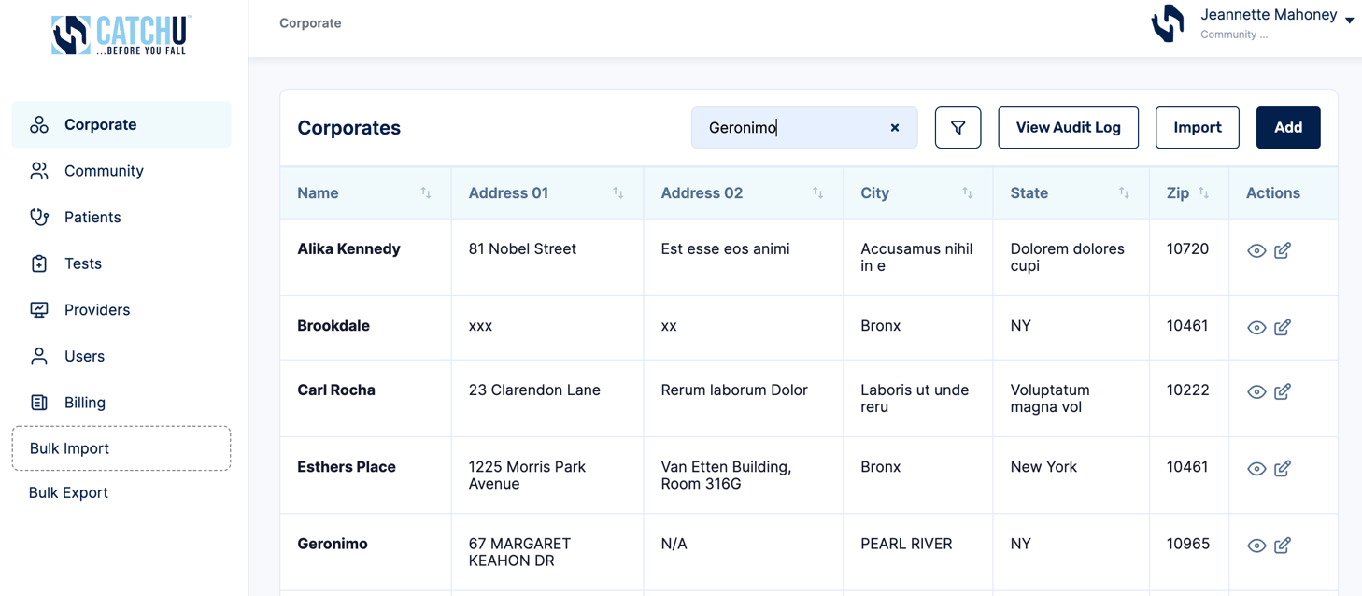
Clicking Edit icon will result in a new pop-up window where corporate information can be revised:

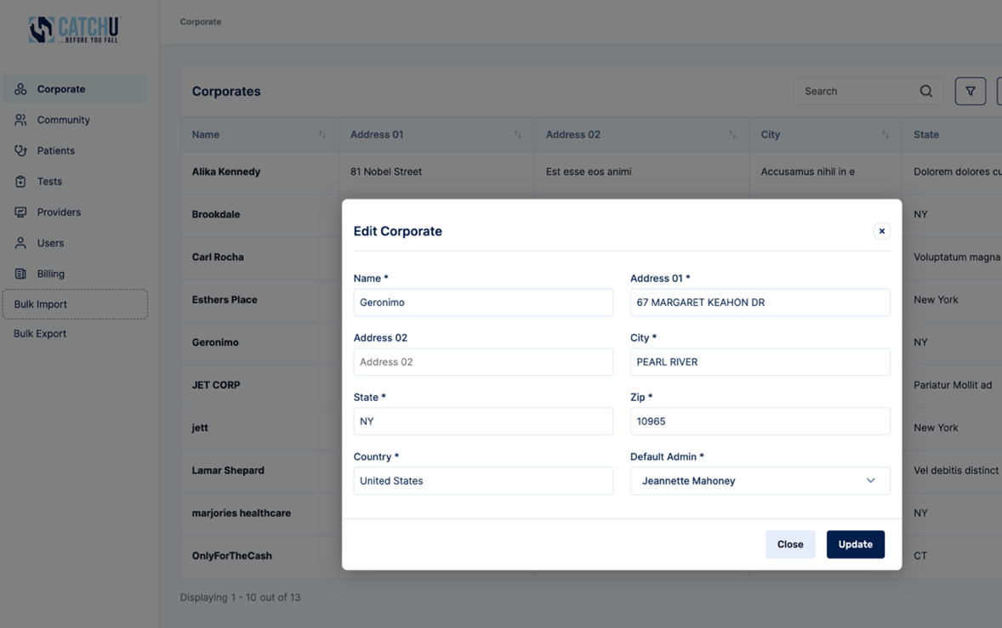

If any information is updated, be sure to click “Update” to save new corporate account details (see red box).

  - View corporate information Community Location Information

In order to view specific corporate community location information, you will first need to identify the corporate location that you are looking to view. For example, find Geronimo on the list (you can also search for it by name in the yellow search box as referenced above) and then click the view icon (see red box below) located in the “Actions” column of the Corporate matrix in the specific corporate row (see black dashed arrow). For the Corporate account named Geronimo (black box), you would need to click the view eye icon (red box) located at end of black dashed arrow (the view button for the Geronimo data row here).
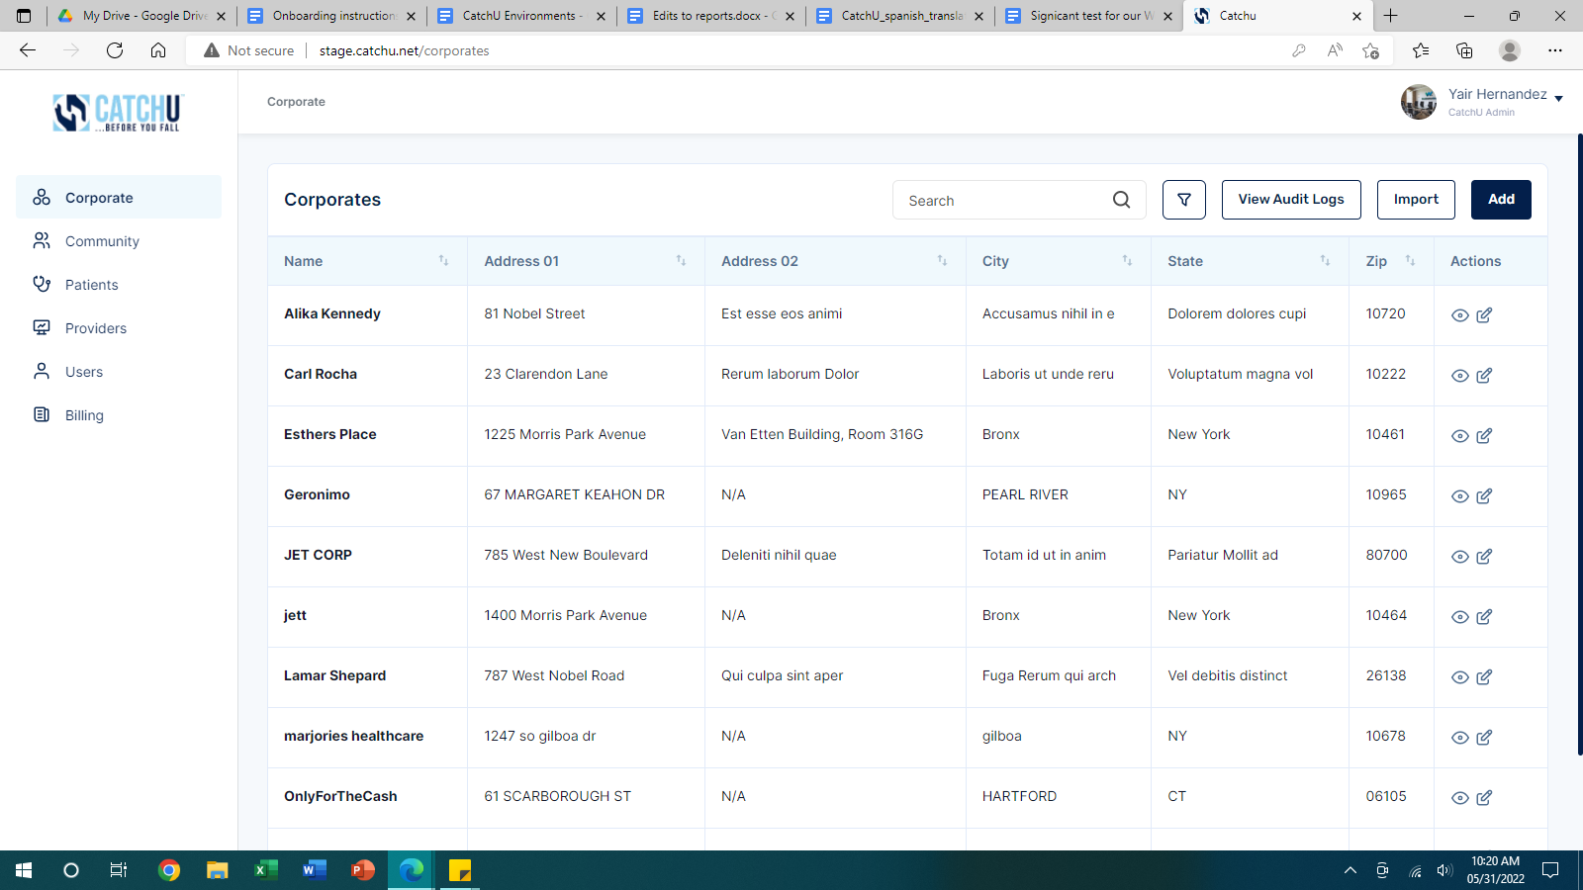

After clicking view, a new screen with information specific to the selected corporate location (in this case “Geronimo”) will appear (see orange box below). Note that by clicking the name “Geronimo” (black box above) you can gain access to the same exact corporate view screen.

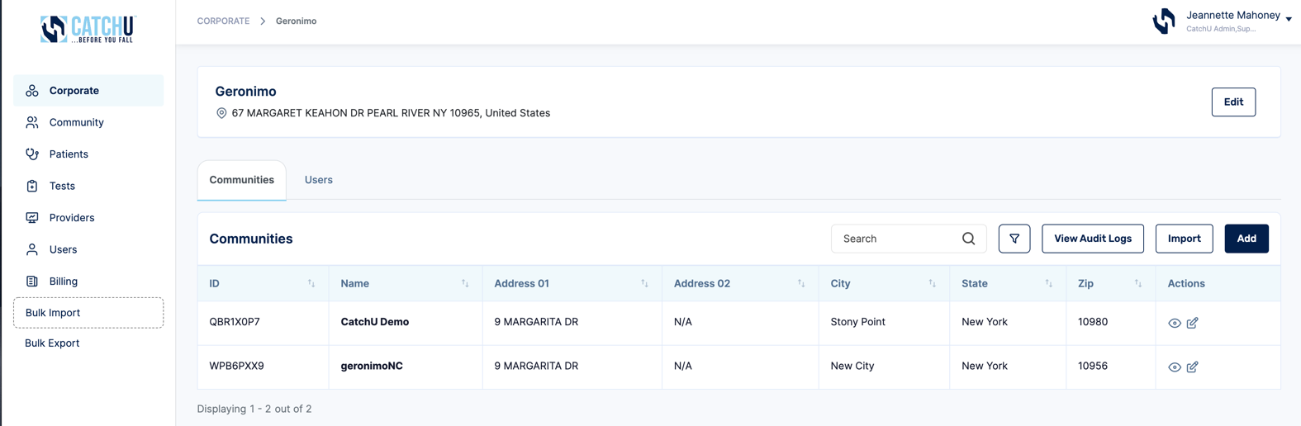

Notice in pink box, each Corporate Account can have a list of Practices or Communities that are associated with the Corporate Account. So, in the above example, both CatchU Demo and geronimoNC are community/practice locations that are linked to the Geronimo Corporate Account. Again, Individual communities or private practices will not be linked to any corporate accounts.

The Users tab (cyan box below), allows you to see all the administrators that have been assigned a role in the Geronimo Corporate Account.

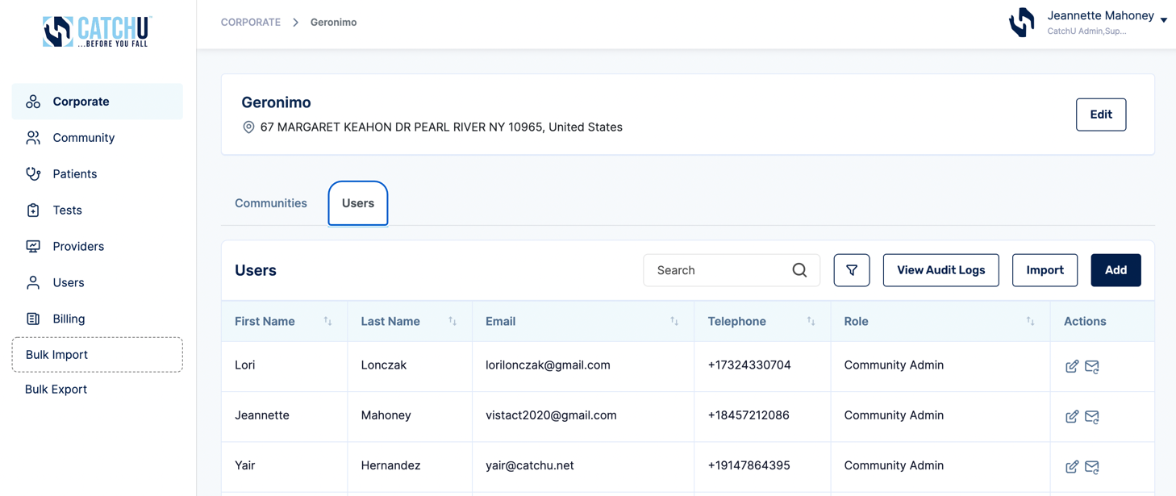

By clicking “Add” (green box above) more users that are to be associated with this specific corporate account can be added:

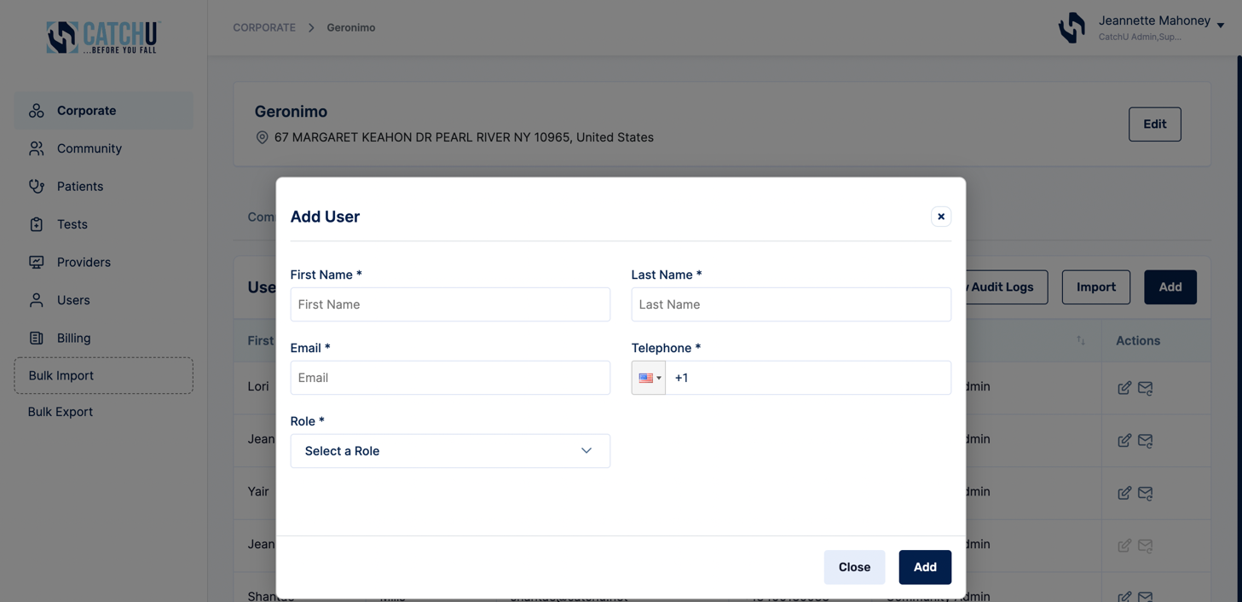

Be sure to fill in above required fields and click “Add” to save new corporate account user details (see red box).

Similar to the corporate import functionality, a series of new corporate account users can be imported by clicking “Import” (green box below):

A new window will pop up and allow you to either upload a completed CatchU .csv template file or one of your existing .csv files with appropriate field mapping (same process as detailed on page 12 of this manual – here the process is different since it is for importing Corporate HQ Administrators or Community Admins).
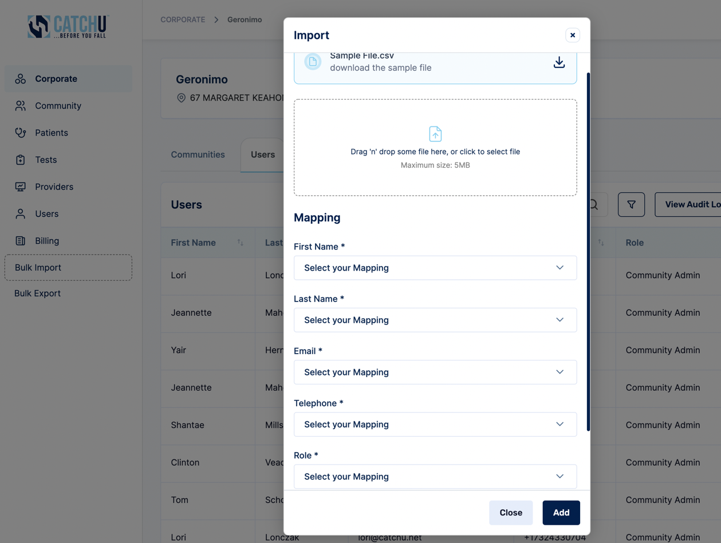

- Audit Logs throughout the Portal

Audit Logs (see orange box below) provide a brief history of actions (create/edit) that have been performed within each record. These logs include brief event descriptions that specify changes that were made within any given record.

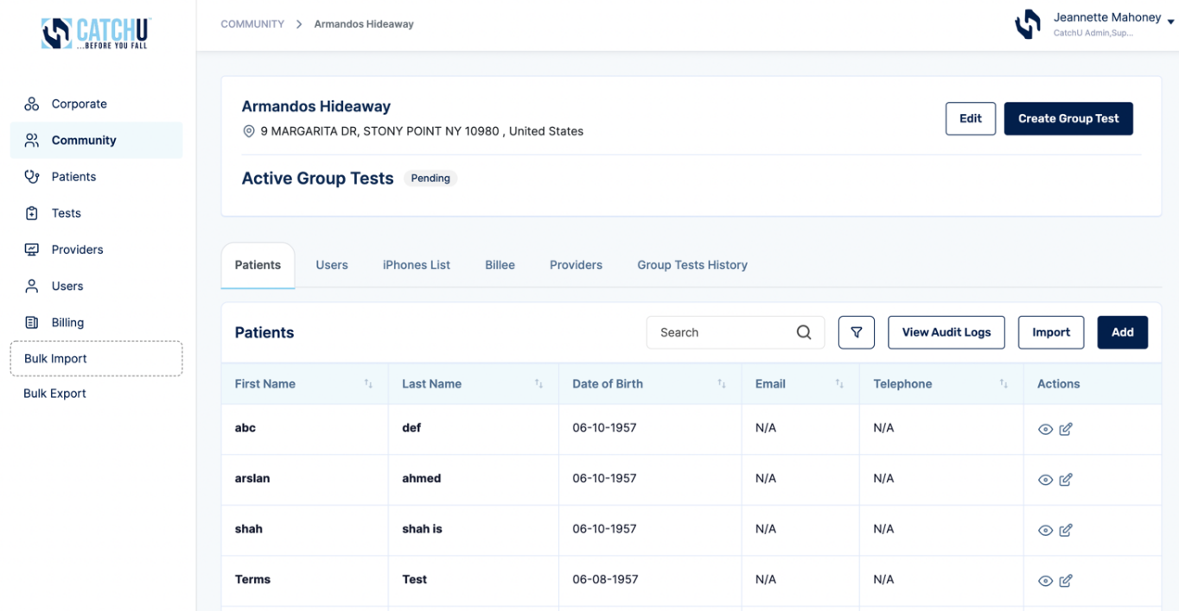

Once a “View Audit Logs” button is clicked (above orange box), a new window will pop-up (below screenshot) that serves to provide a log of all changes or edits (aka “Events”) that were made by a specific User at a specific time. The below example is an Audit log for patients under the community named Armandos Hideaway.

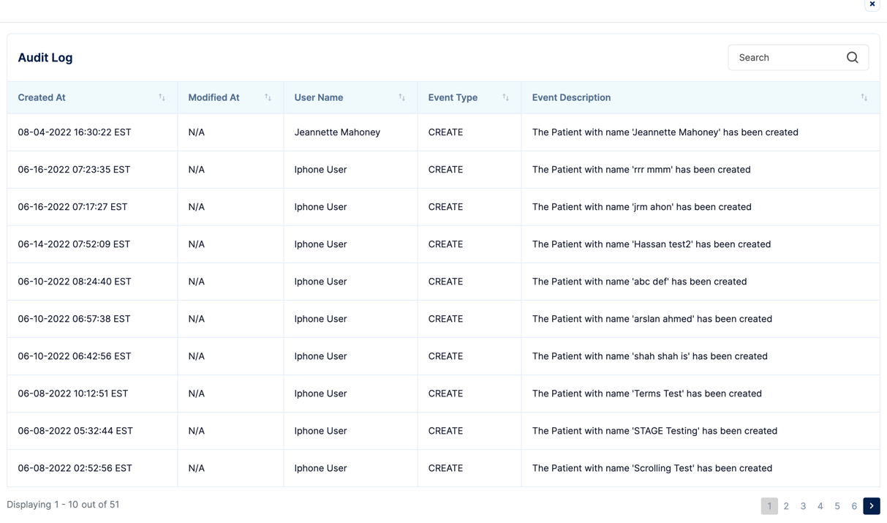

The “View Audit Logs” feature is available for most records including: Corporate Accounts, Community Accounts, Patients, Users, iPhone lists, Billees, Providers, Patient Test History, and Billing activity.

- Ordering Tests

  - Tests to Schedule & Upcoming Tests - Left Side Toolbar

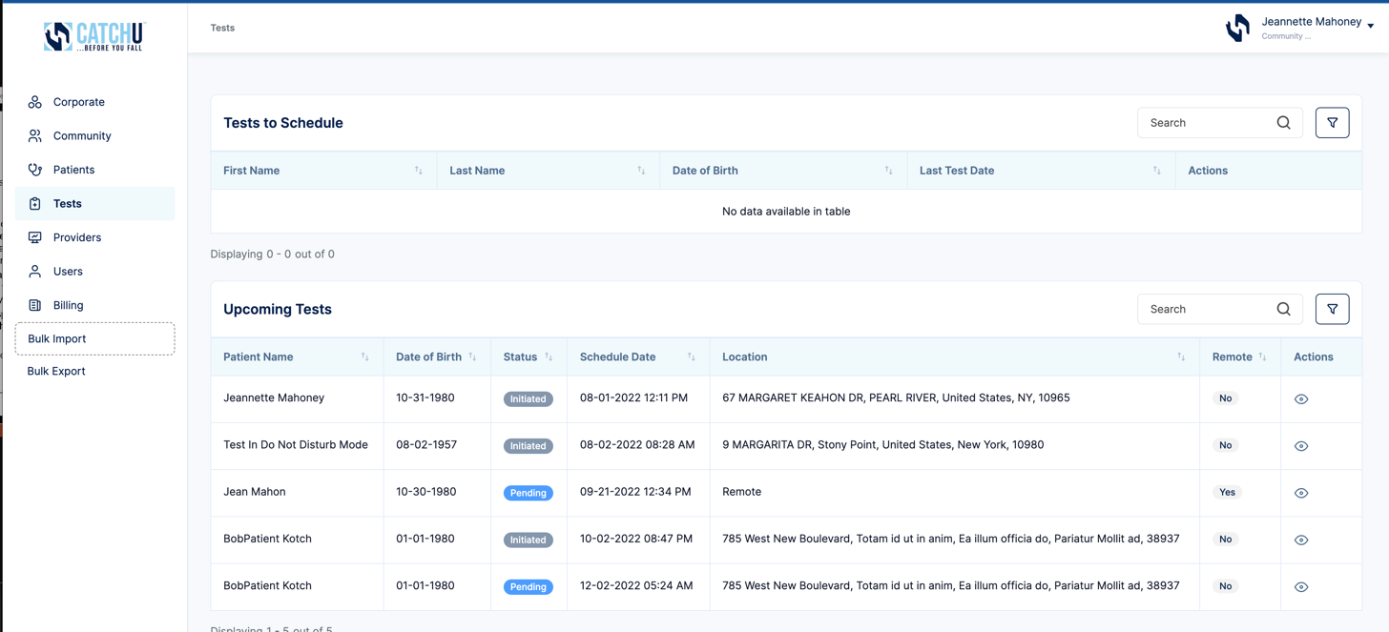

Under the Actions column, if you click the View Icon (red box above), a new pop-up window (screenshot below) will appear that will show patient details and allow you to order tests for each patient.

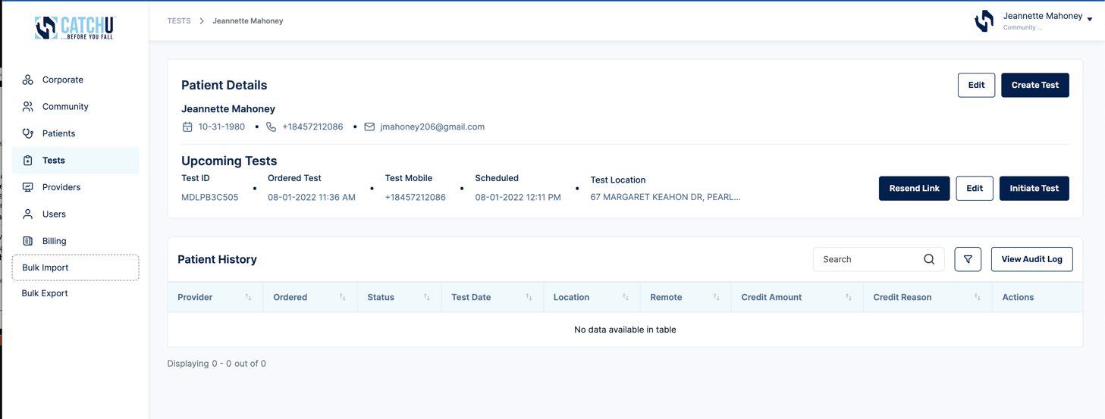

  - Ordering Tests from Patients Option on Left Side Toolbar

Similarly, you can click the Patients option on the left side toolbar (blue box) and then find or search for the patient for whom you are wanting to order a test.

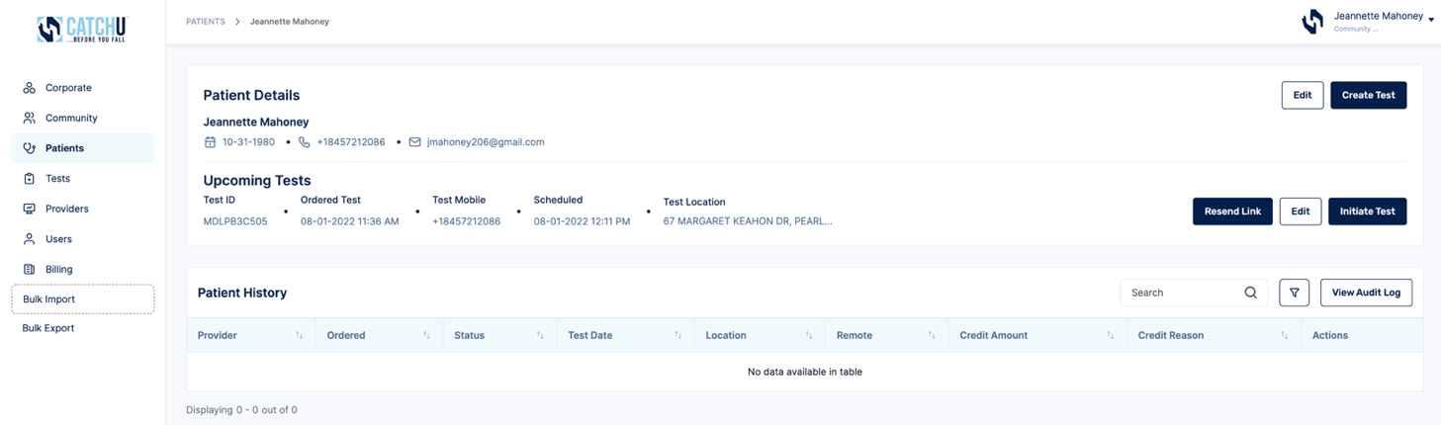
Once you locate the patient, click the View Icon (red box above) on the patient’s data row, and the same pop-up window (as above) will populate, allowing you to schedule a test.

  - Ordering Tests with the Community Option - Left Side Toolbar

Lastly, you can also order tests from the Patients tab within the Community Option on the Left Side Toolbar. Simply find or search for the patient for whom you are looking to order a test.

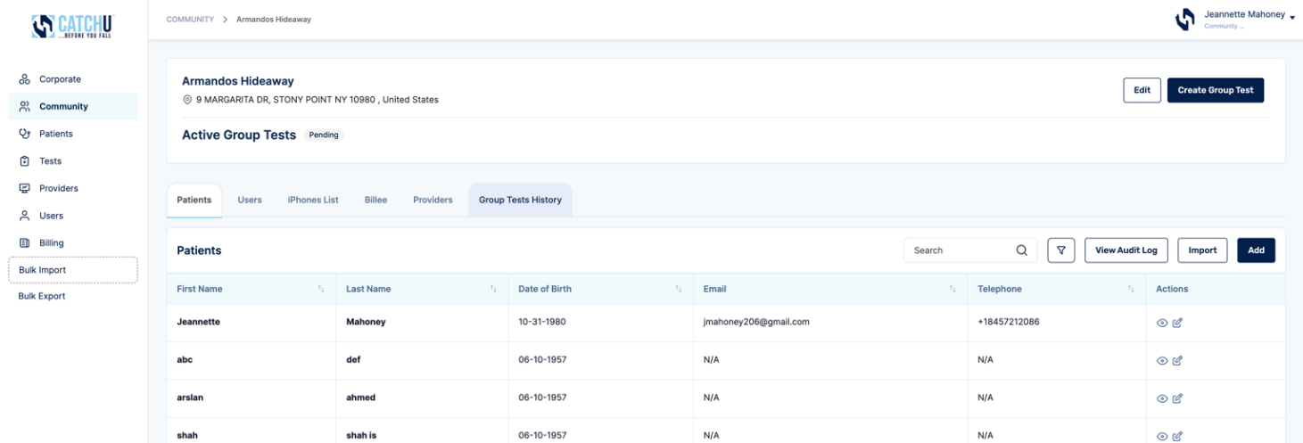

Once you locate the patient, click the View Icon (red box below) on the patient’s data row, and the same pop-up window (as above) will populate, allowing you to schedule a test.

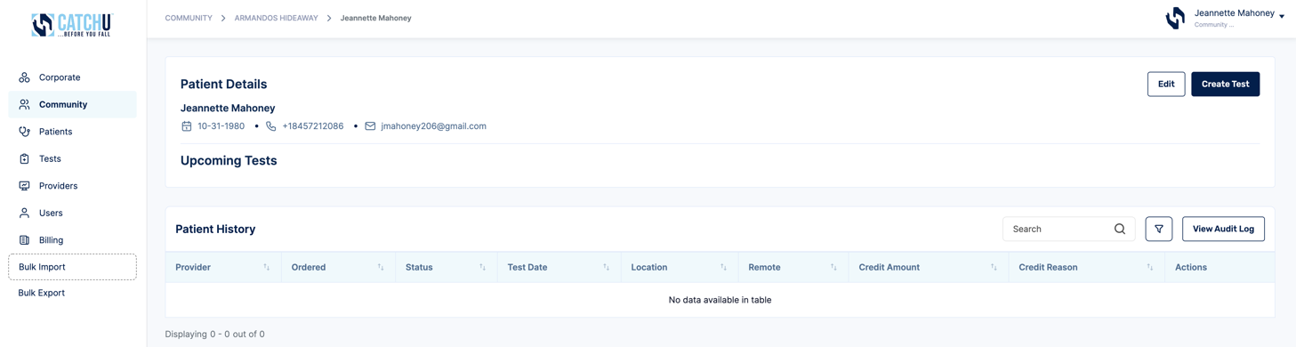
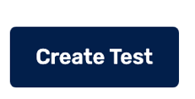
  - Create test:

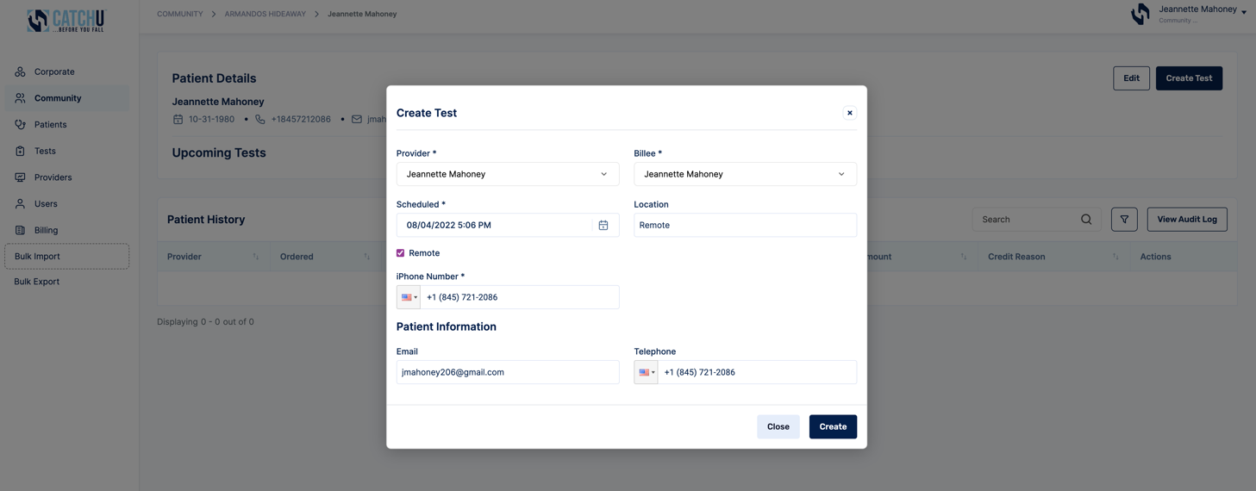

Click “Create” (red box above), and the patient’s dashboard now looks like this:

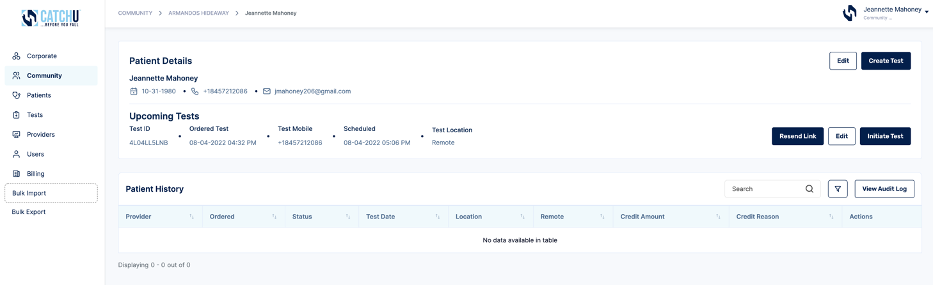
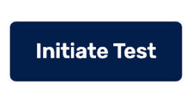
  - Initiate Test :

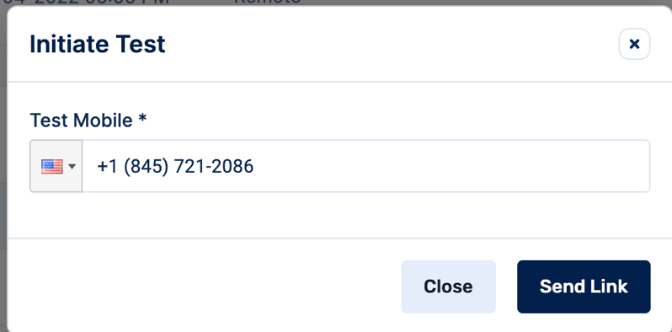

By hitting Initiate Test, an instantaneous text message will be sent to the patient’s iPhone or Android from our CatchU telephone number which is +1-845-712-4820. Please be sure that the receiving mobile telephone number is an iPhone 7 or greater or Android 5.0 or greater. If the patient is unsure, suggest having them take CatchU on an office iPhone or Android.

- CatchU iPhone/Android App & Process

You are probably curious about what patients will see after a test is initiated in the portal. In what follows, we will walk you through the process that patients will complete when taking a CatchU test. First time users will be required to download the CatchU App from the App store.

Here is an example of the text message patients will receive after a test has been initiated on their behalf.

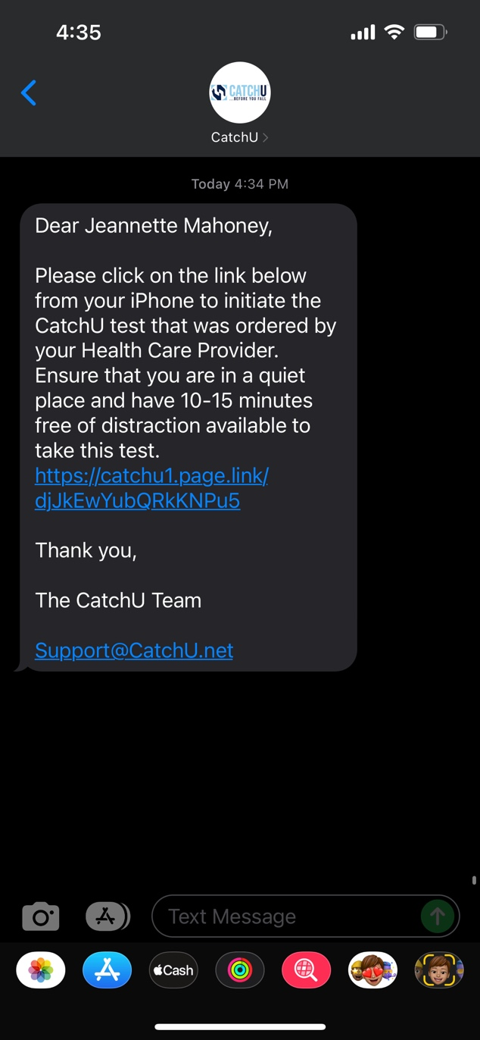
They will need to click this link to be directed to download the CatchU app – see next screenshot.

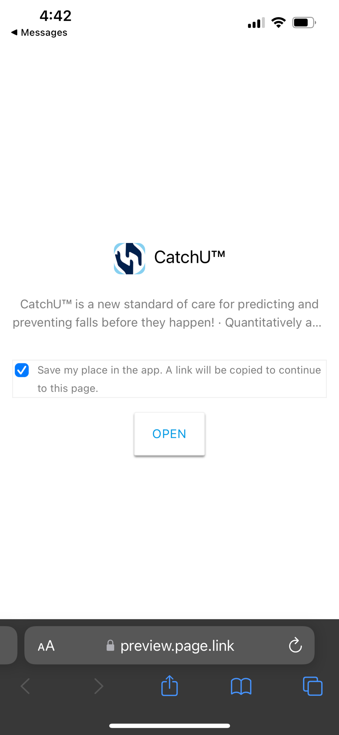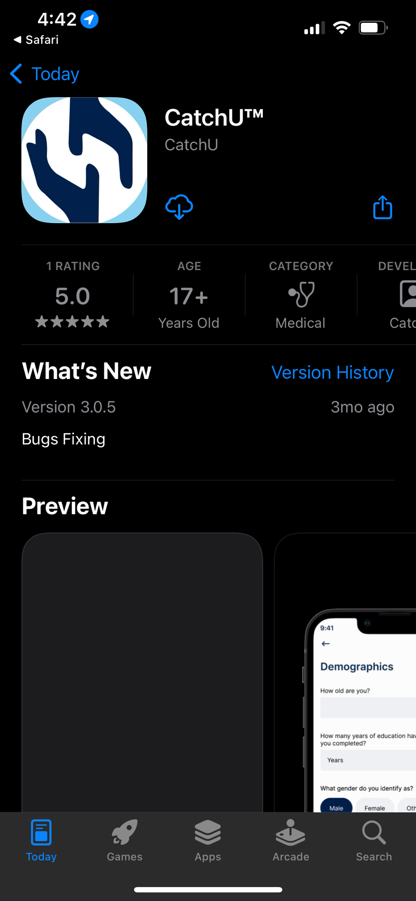
®

®

They will then click “open” to get to Apple App Store – see next screenshot.

They will then click “get” to download CatchUTM from App Store to their iPhone. Once the download is complete, they will need to click Open– see next screenshot.
GET
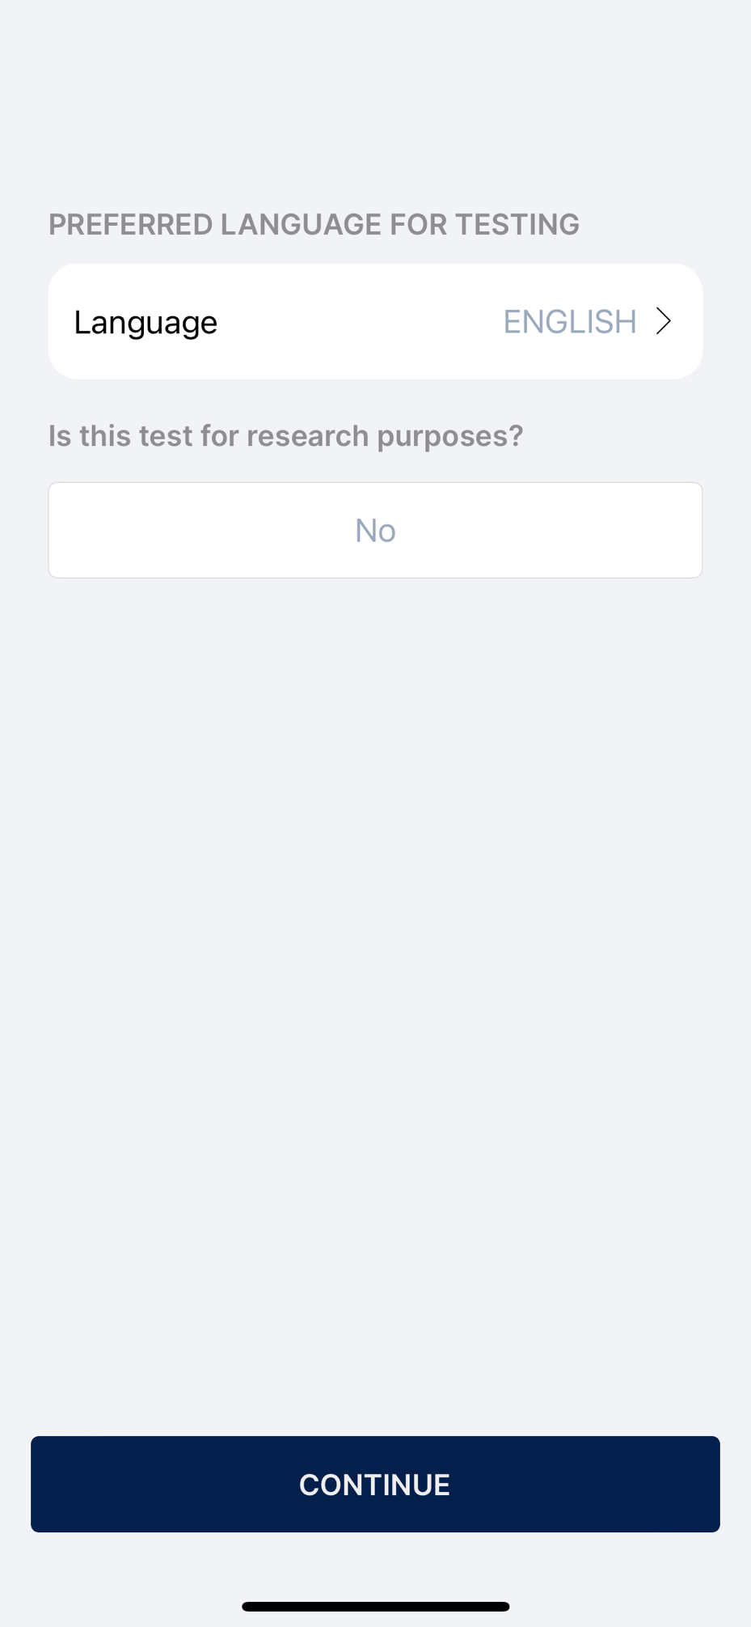

CatchU - opening screen
1st series of questions: Preferred language can be English or Spanish. For clinical testing, Research Purposes question is defaulted to No. Then click Continue…
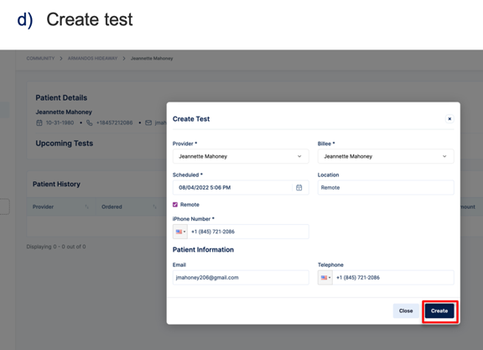
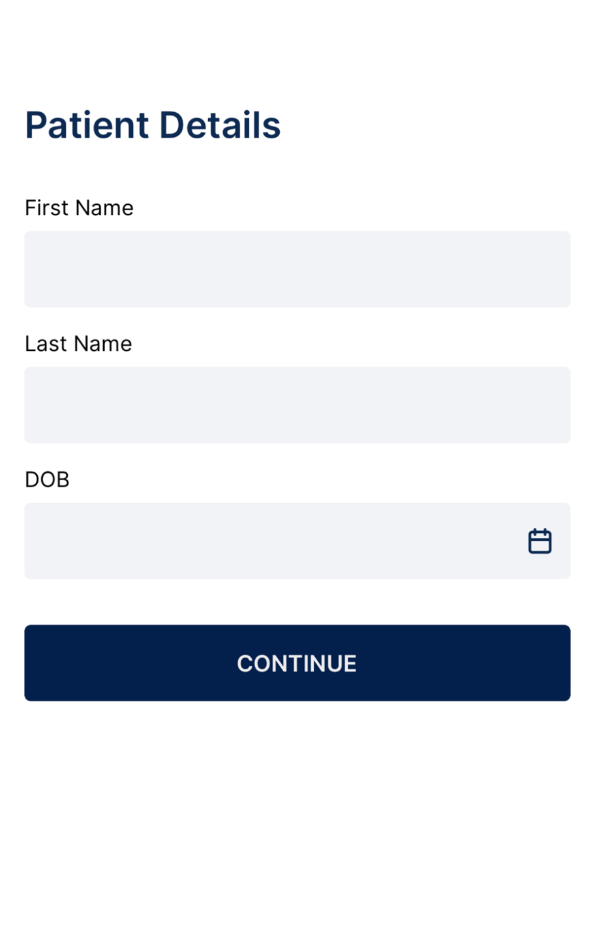
These Patient Details (First Name, Last Name, and DOB must match exactly what was entered in the portal for the patient (see page 43) in order for the patient to be able to advance to the test without receiving an error message.
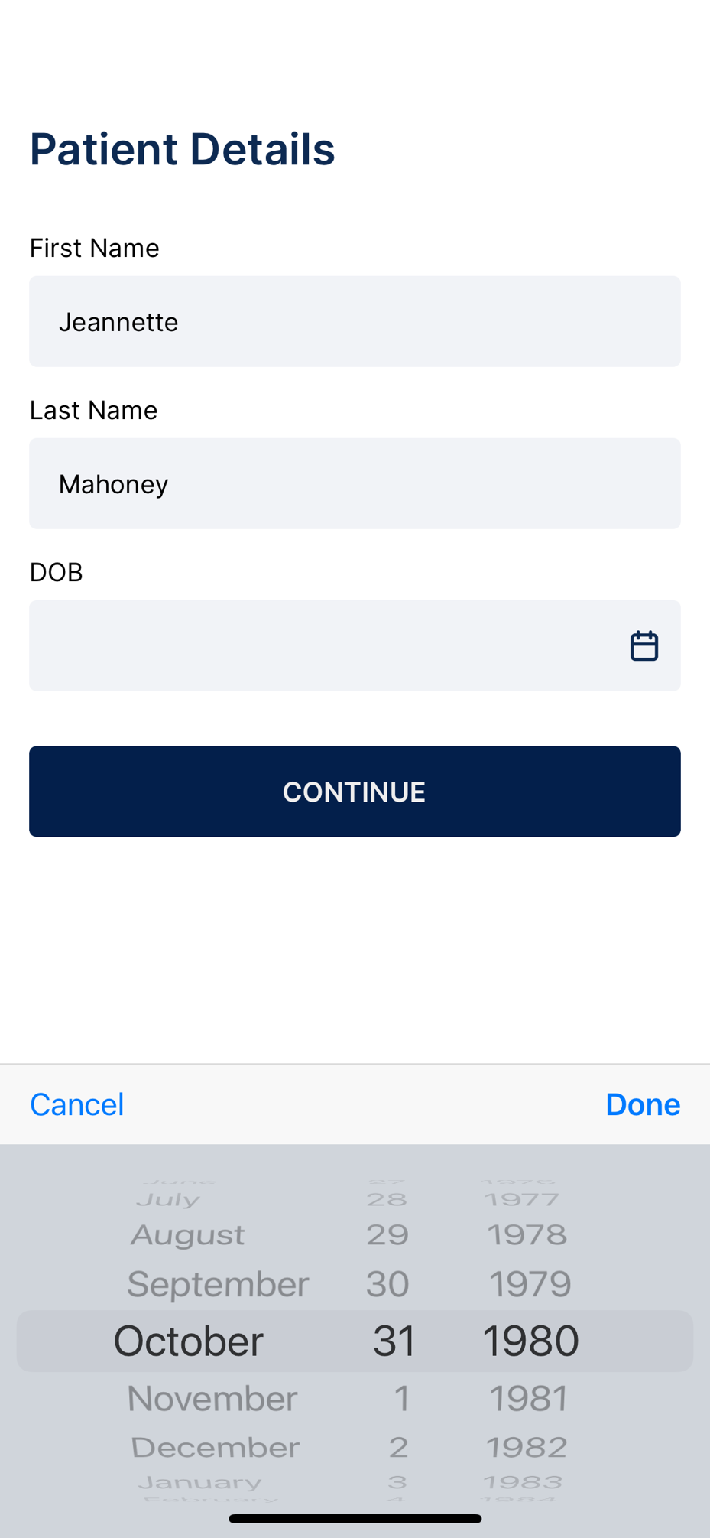
Patient Details Patient enters First Name, Last Name, and Date of Birth (which has a date selector), then presses Continue.
Patients will have the opportunity to read through the Terms and Conditions. If they accept, they will advance to the next screen. If they decline, the provider will receive an email relaying that the patient did not accept the terms and conditions and therefore testing was not possible at this time.

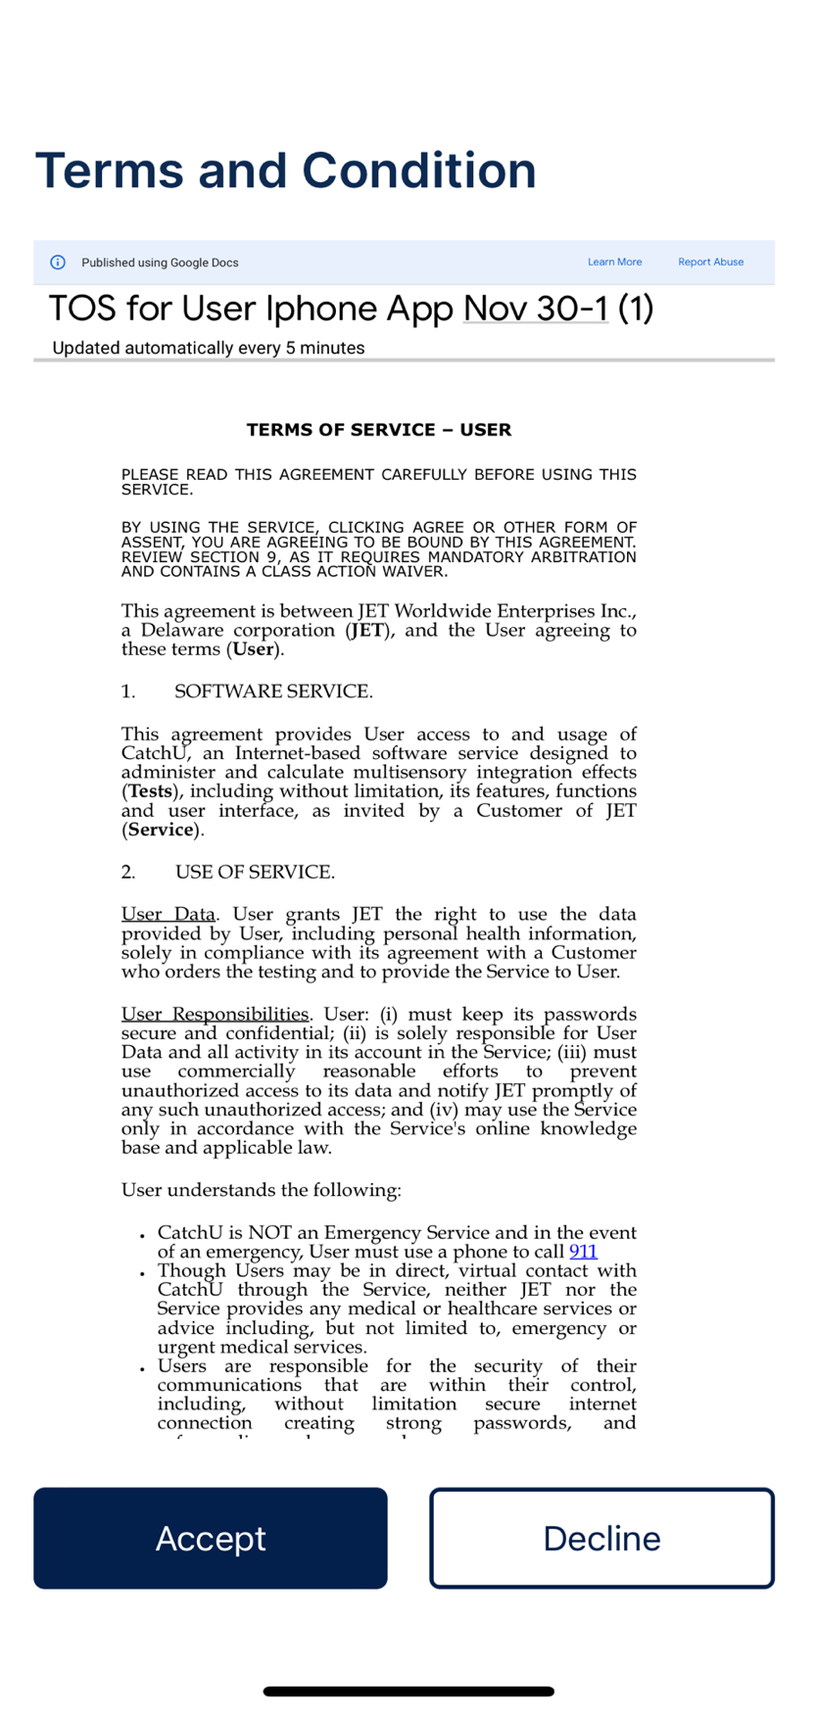
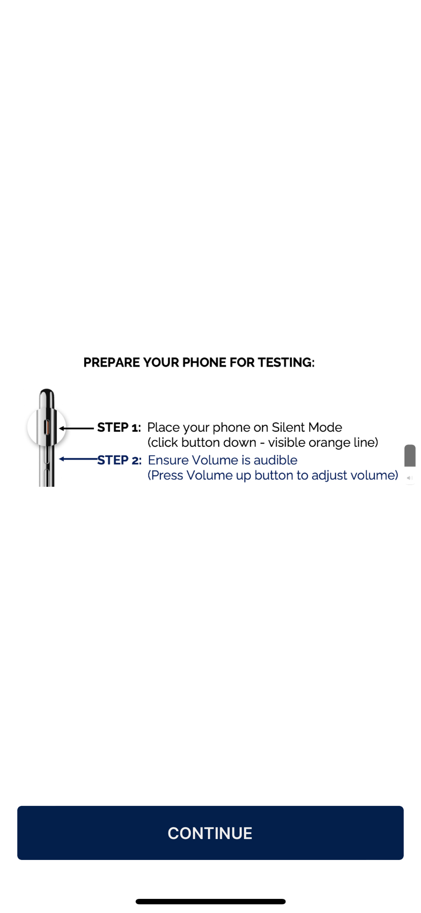
Upon accepting our Terms and Conditions, patients will be made aware of how to set up their phone mode & volume for testing. To avoid any incoming notifications/phone calls, telephone can be set to Do Not Disturb mode, but this is optional.

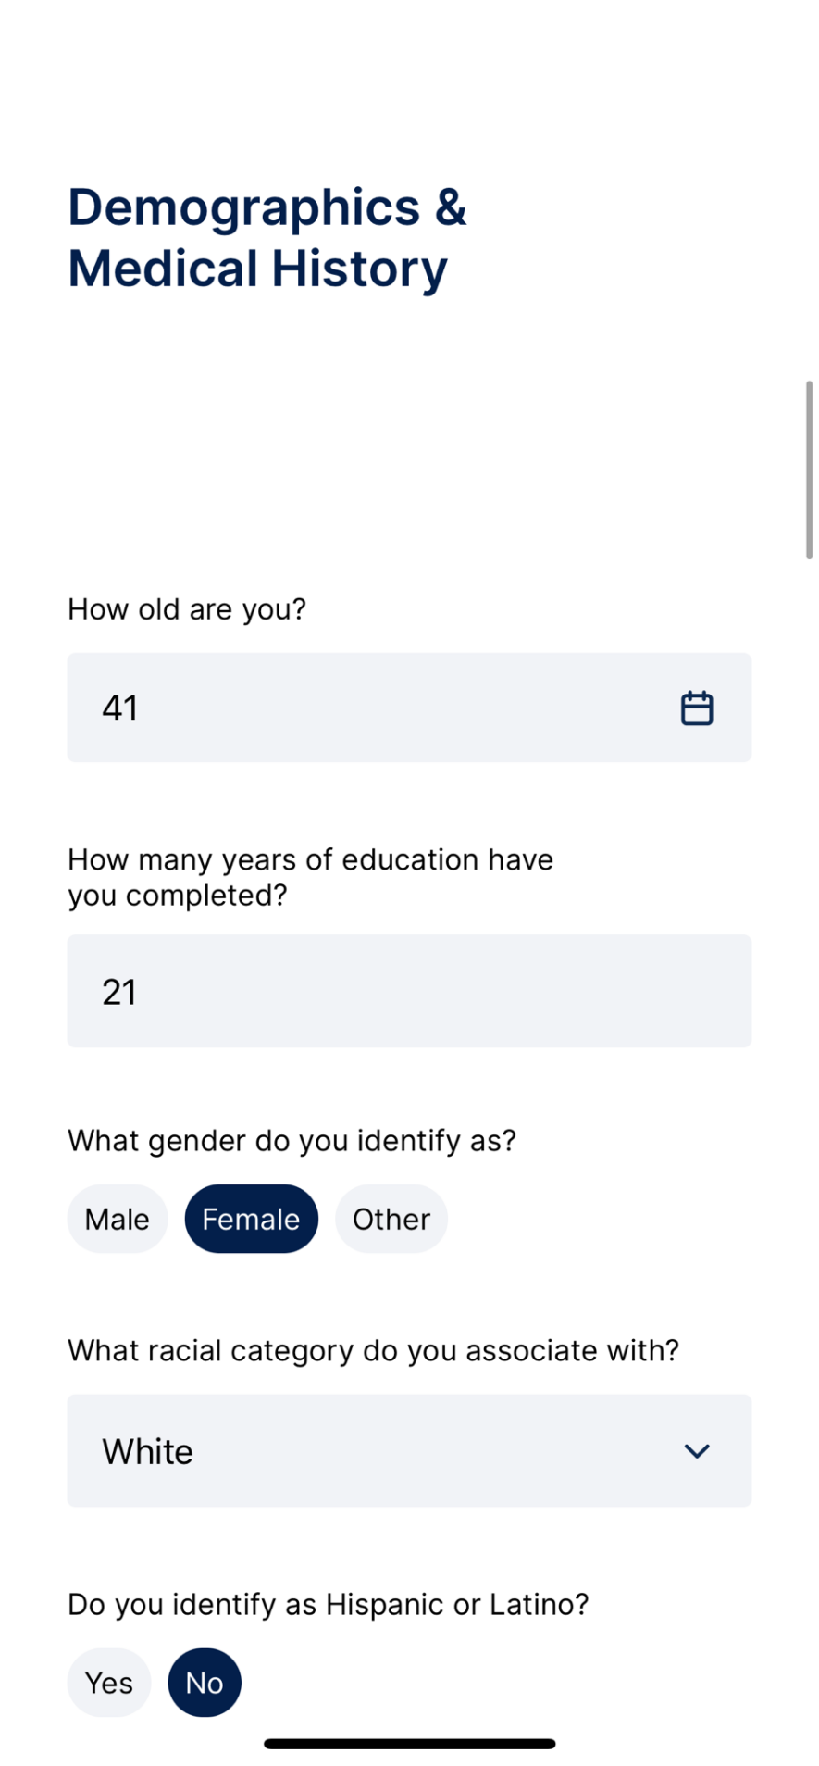
Patients will then be asked to fill in their Demographic & Medical History. This part is very important because information endorsed here will be used in conjunction with the patient’s performance on the CatchU test in order to send the patient’s provider tailored recommendations. The next few pages show all the questions we ask:
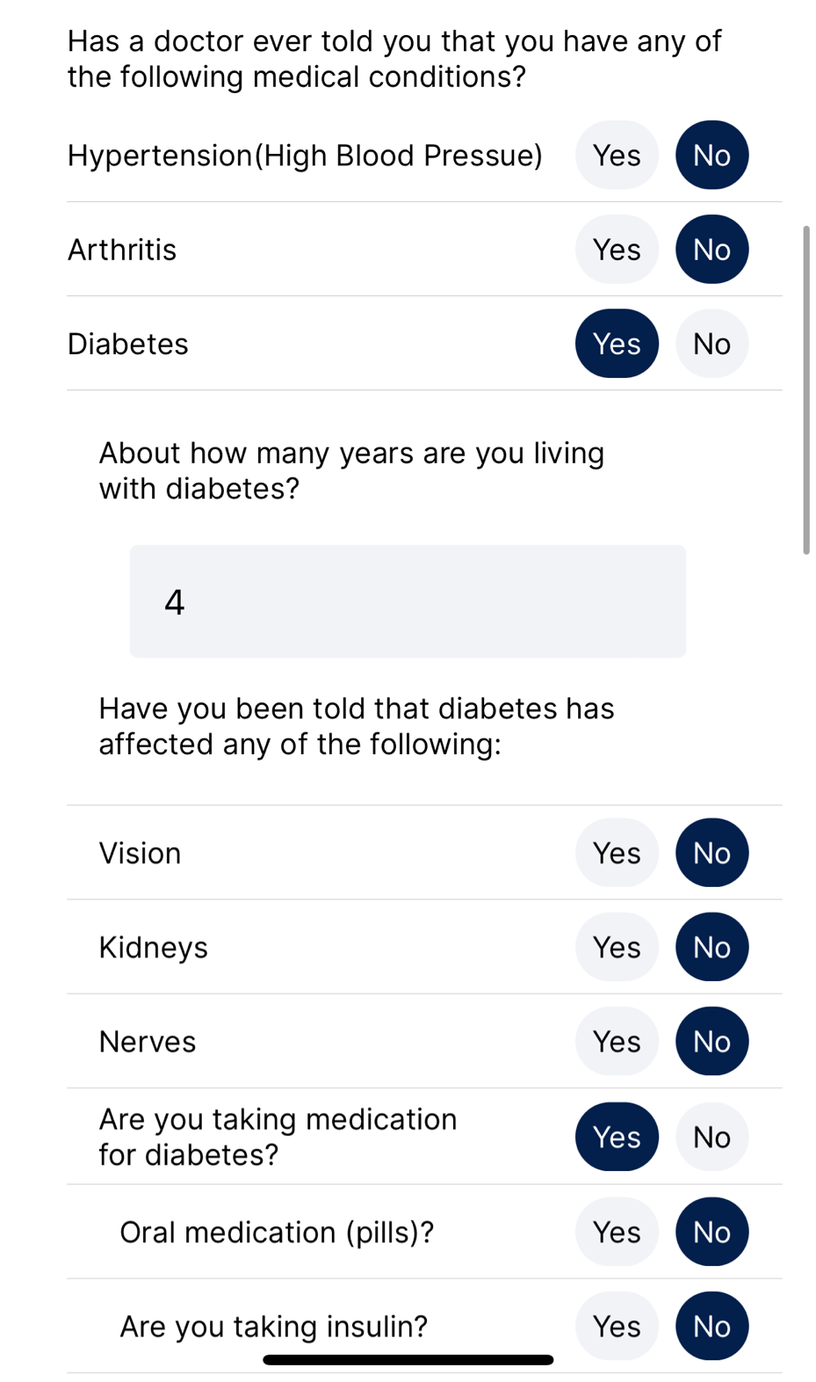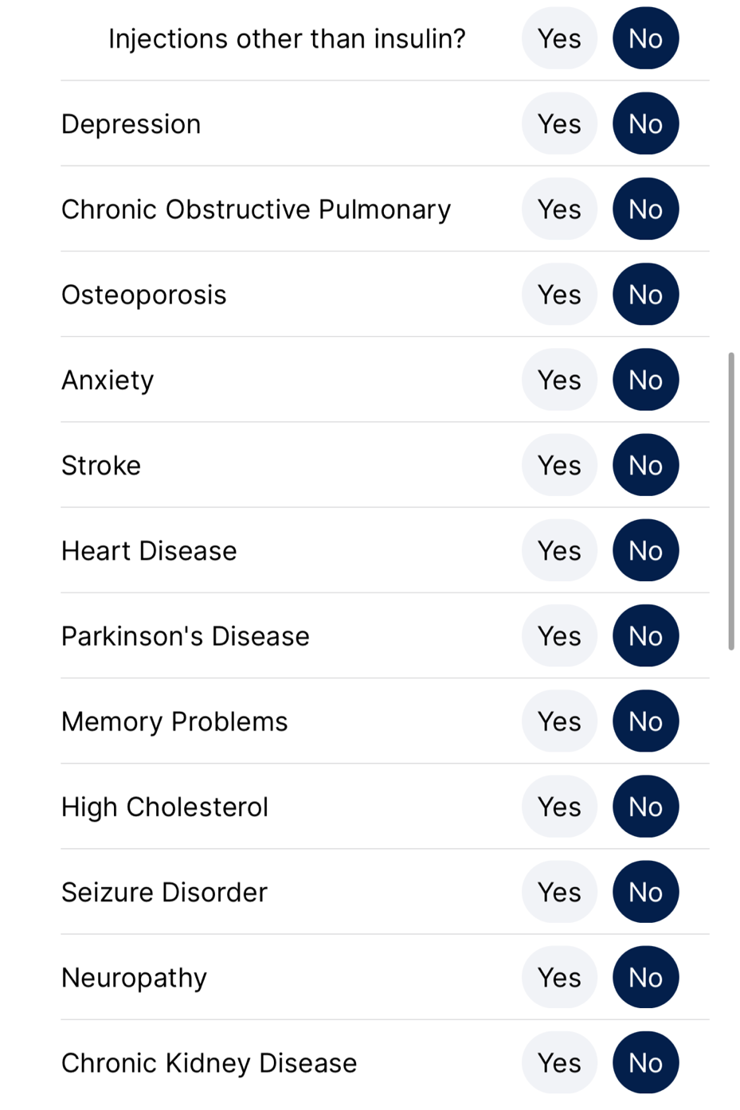

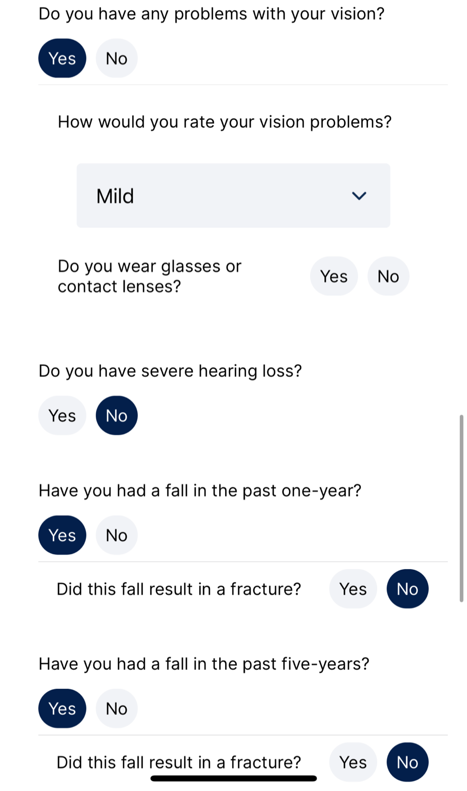

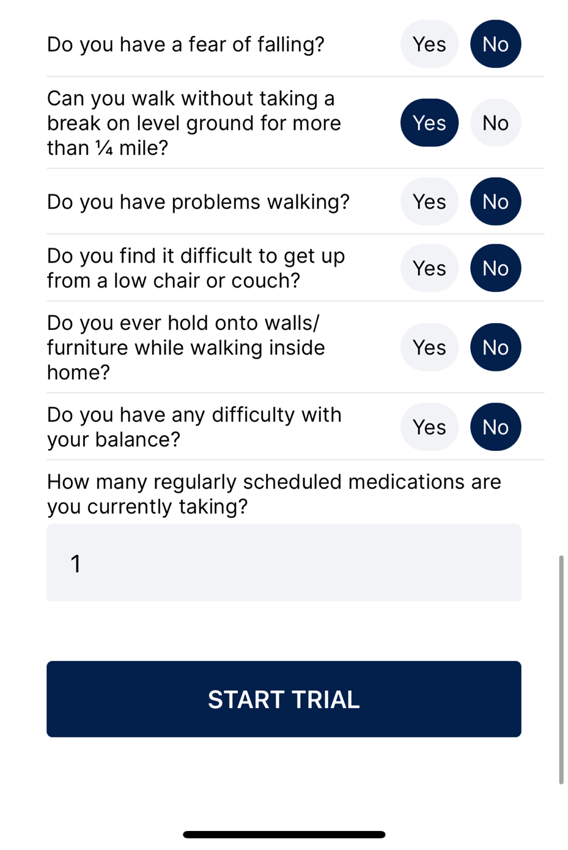
Patients will then hit Start Trial. If any questions were inadvertently skipped, the patient will be redirected to provide a response for missing questions and then will be able to hit Start Trial again. Once accepted, this will prompt the practice test – see next page.
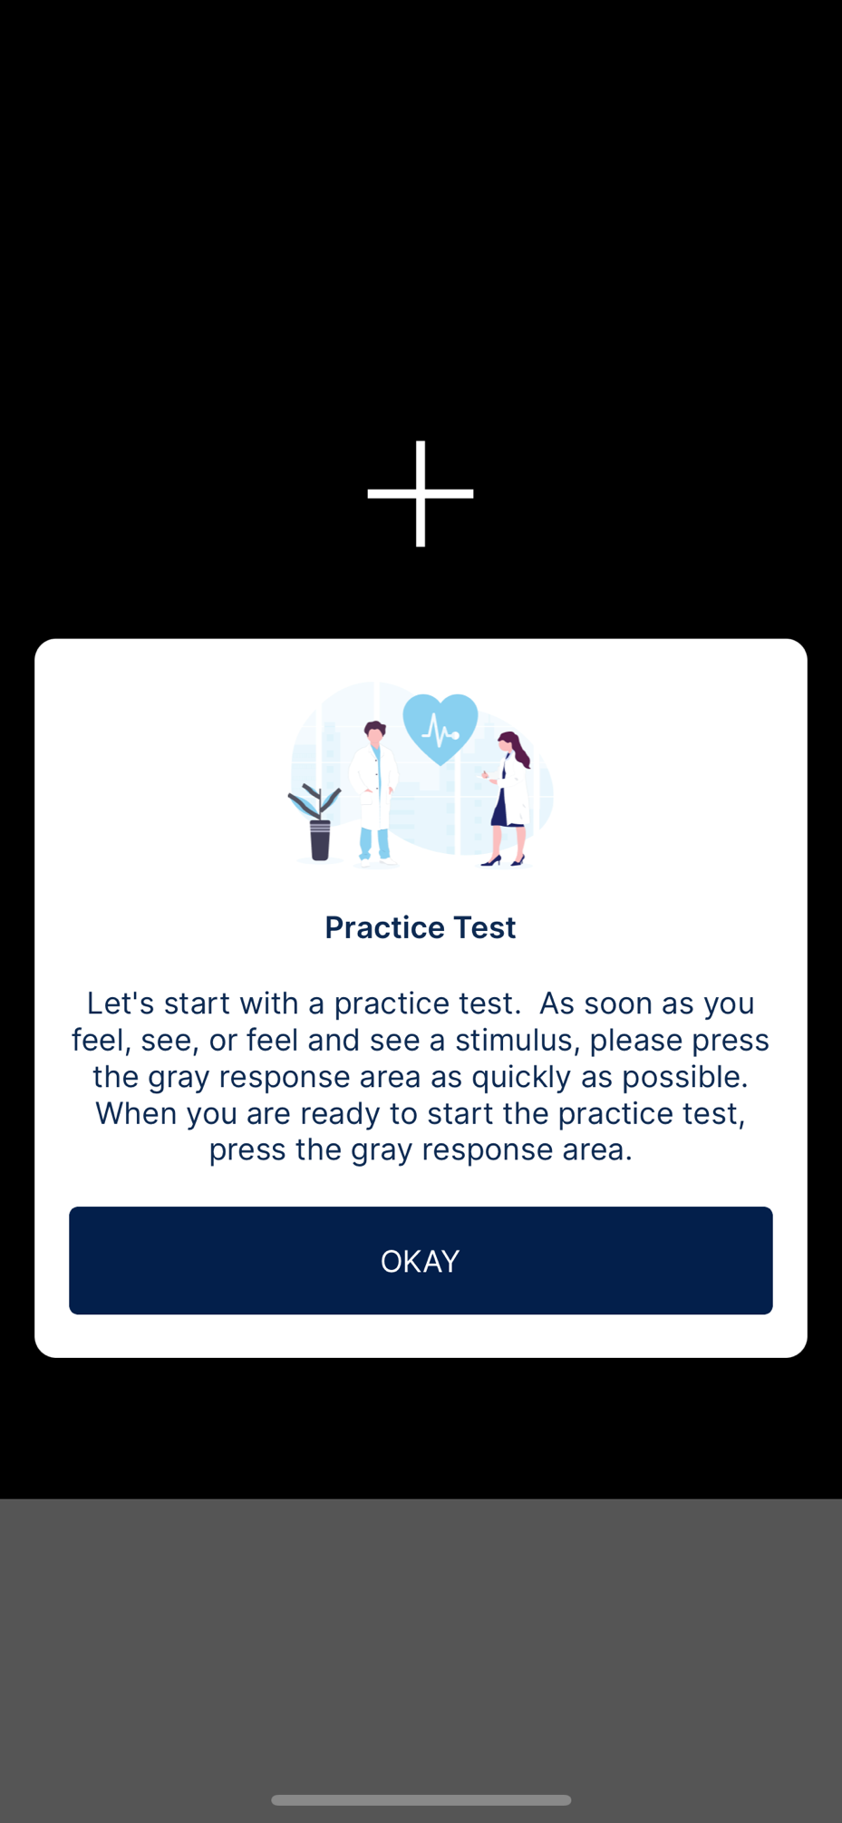
Here patients will be presented with 15 trials. They will be asked to keep their eyes fixated on the cross. As soon as they feel, see, or feel and see any stimuli, they will be asked to tap the gray response area. If they have trouble with this quick practice trial, they will have the opportunity to take the practice trial one more time before the test is deemed invalid.
CLICK TO START THE PRACTICE TEST
CLICK HERE TO RESPOND TO RESPOND
Here are the visual alone stimuli – as soon as they see these asterisks pop up on the iPhone, they should tap the gray response area. There will also be time when the phone vibrates with or without these visual asterisks. Patients are asked to respond to all stimuli as quickly as possible since we are measuring their reaction time to each stimulus.
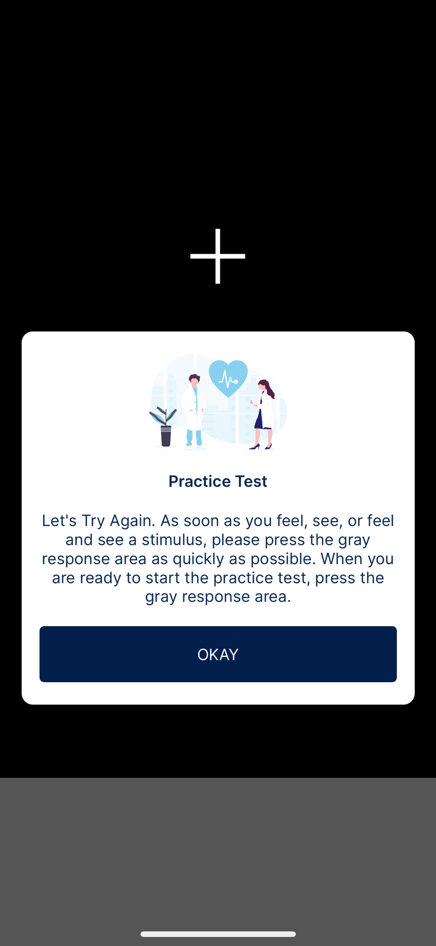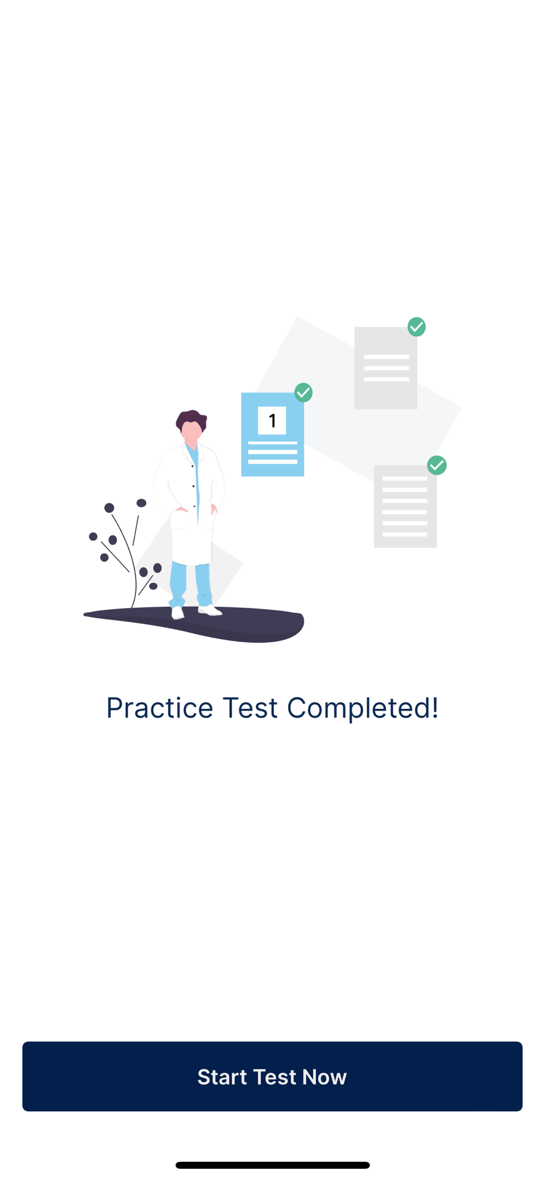
If the patient has trouble with this quick practice trial, they will have the opportunity to take the practice trial one more time before the test is deemed invalid.
If the patient passes the practice test, they will see this message and then hit “Start Test Now” button
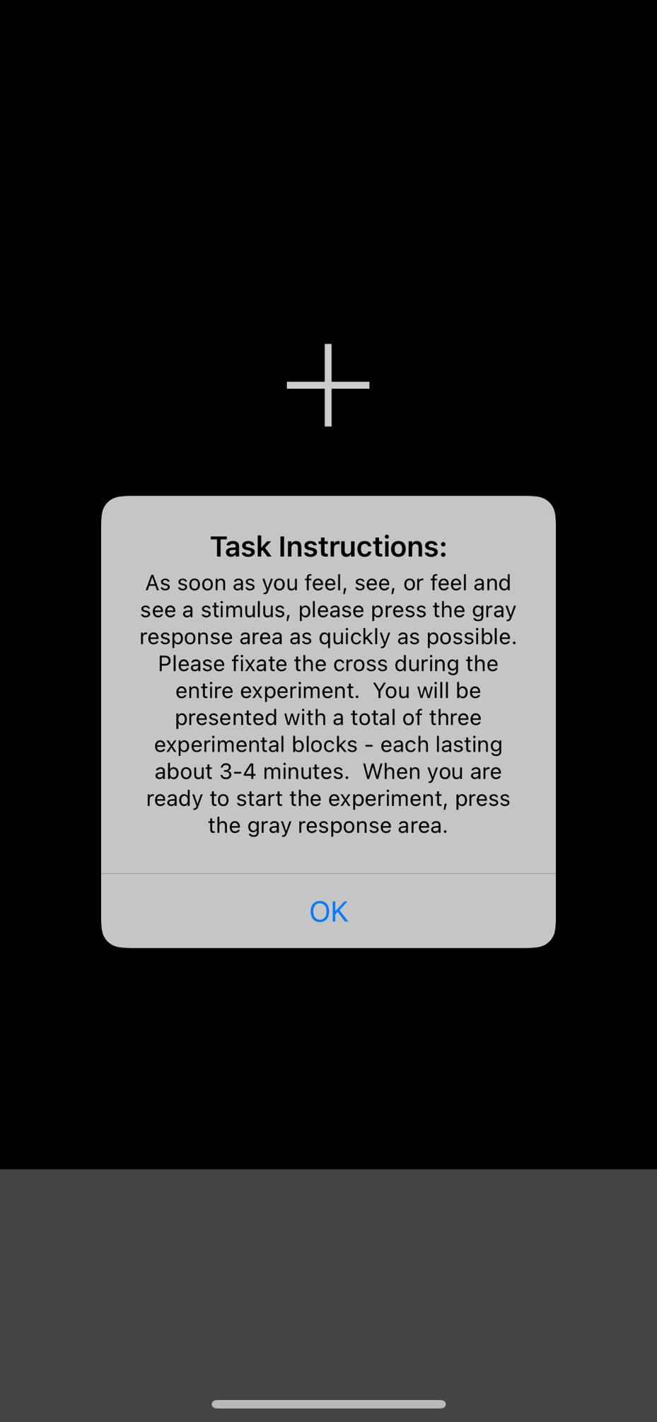
The patient will be then presented with the instructions for the actual CatchU test which will take a total of about 10 minutes. This should be taken in a quiet place free from all distractions
CLICK HERE TO RESPOND TO RESPOND
In the actual test, they will receive 3 three-minute test blocks comprised of randomly presented visual (like screenshot here), sensory, and combined visual-sensory stimuli that they will need to respond to as quickly as possible.
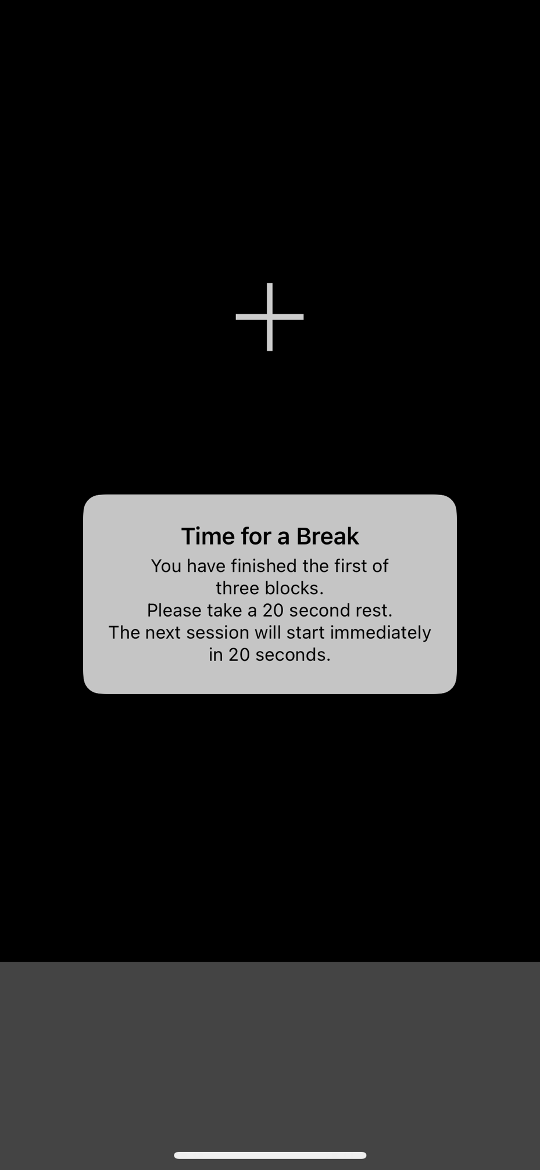
In order to enhance concentration during testing, we have provided patients with a 20 second break/rest before starting the 2nd and the 3rd test blocks.
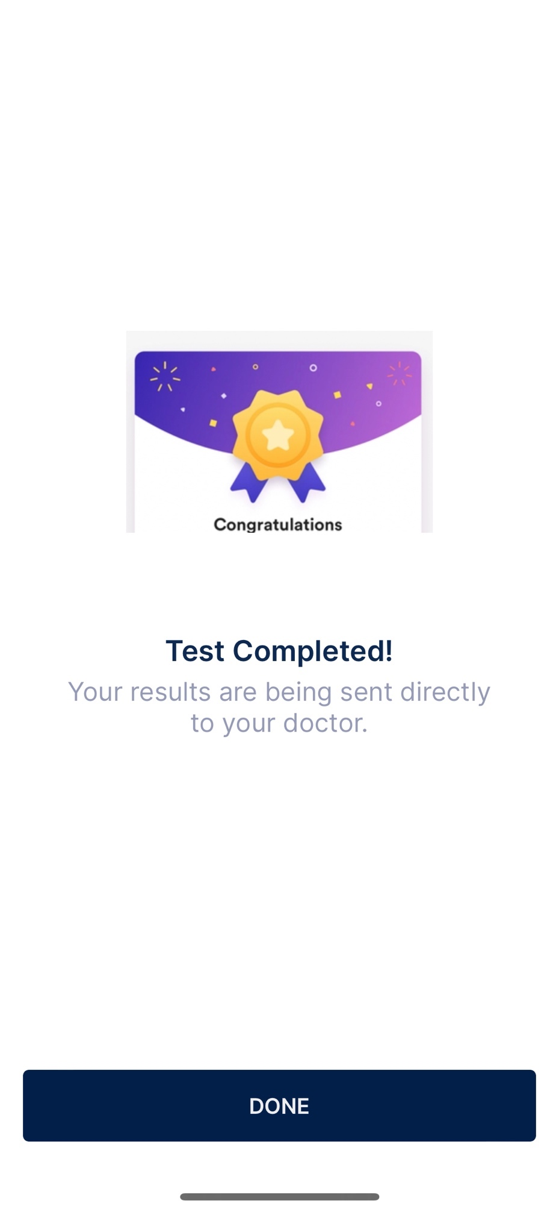
Once the patient completes the three test blocks, they will be notified that the test is complete and that the test results are being sent directly to their doctor. The patient can then hit Done and the CatchU app will close.
- Billing

  - Tests Billings

Selecting the “Billing” tab on the left side toolbar (blue arrow) will allow you to see all financial information linked to the User’s associated communities. If your user is related to more than one community, corporate or practice you will be able to see the financial information of all these institutions. Once the “Billing” left side toolbar is selected you will be able to see all the pending (Test Billings tab) and Past Invoices (Invoices tab) linked to the User’s associated communities.
.

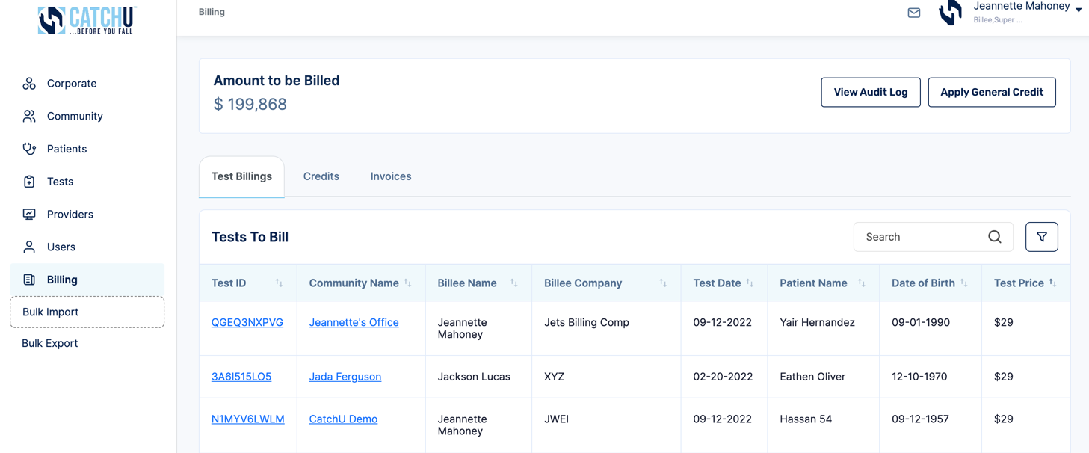
  - Past Invoices

Selecting the “Billing” tab on the left side toolbar (blue arrow) will allow you to see all financial information linked to the User’s associated communities. If your user is related to more than one community, corporate or practice you will be able to see the financial information of all these institutions. The “Past Invoices” tab presents the history of all bills linked to the User’s associated communities.

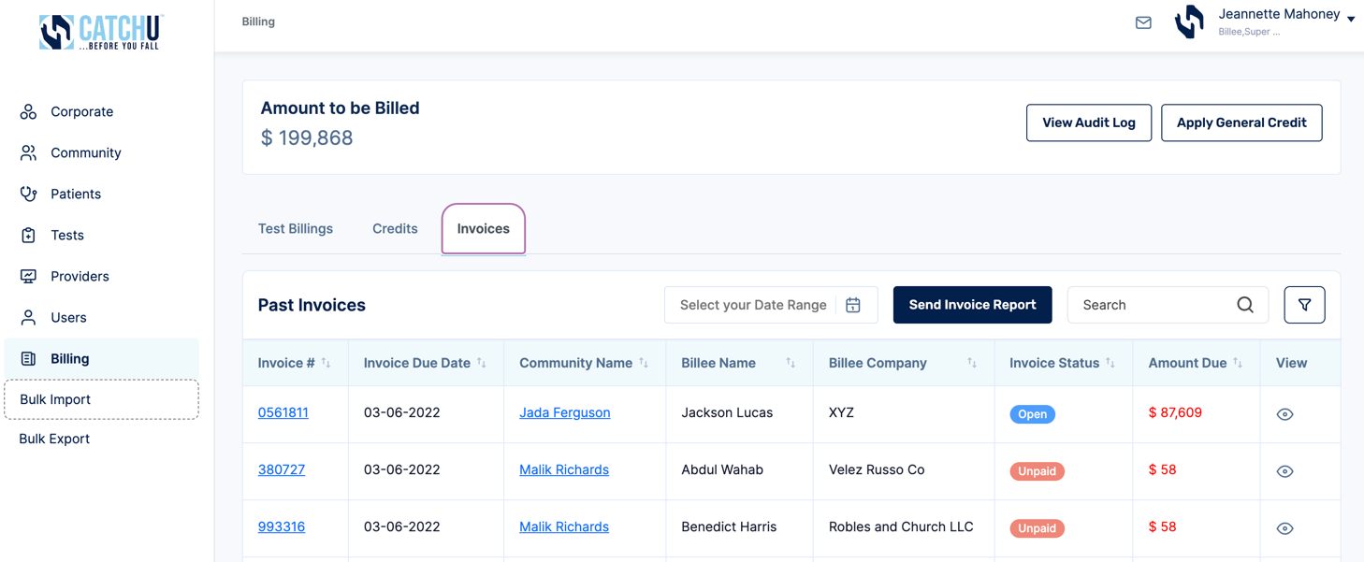

  - Creating a Bill.com account
You can create your bill.com account by navigating to Bill.com (here). The online billing platform that sends invoices to customers. Users will need to create a bill.com account to pay for CatchU services. Special billing functionality can be made directly in bill.com: see https://help.bill.com/hc/en-us/categories/115000285666-Account-Fundamentals

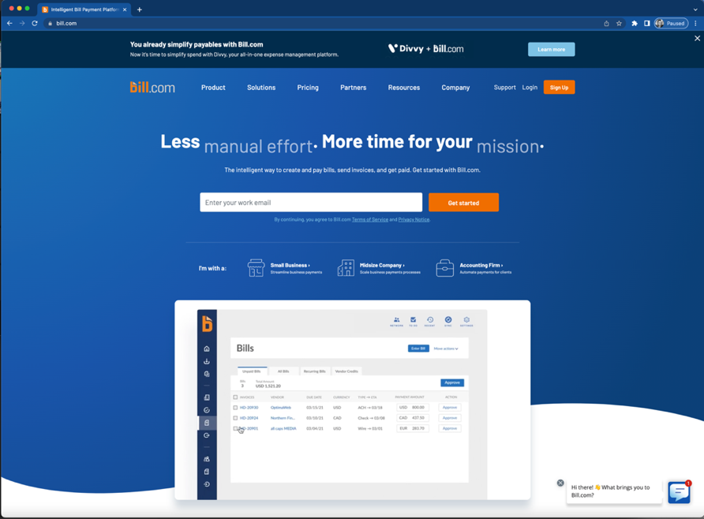

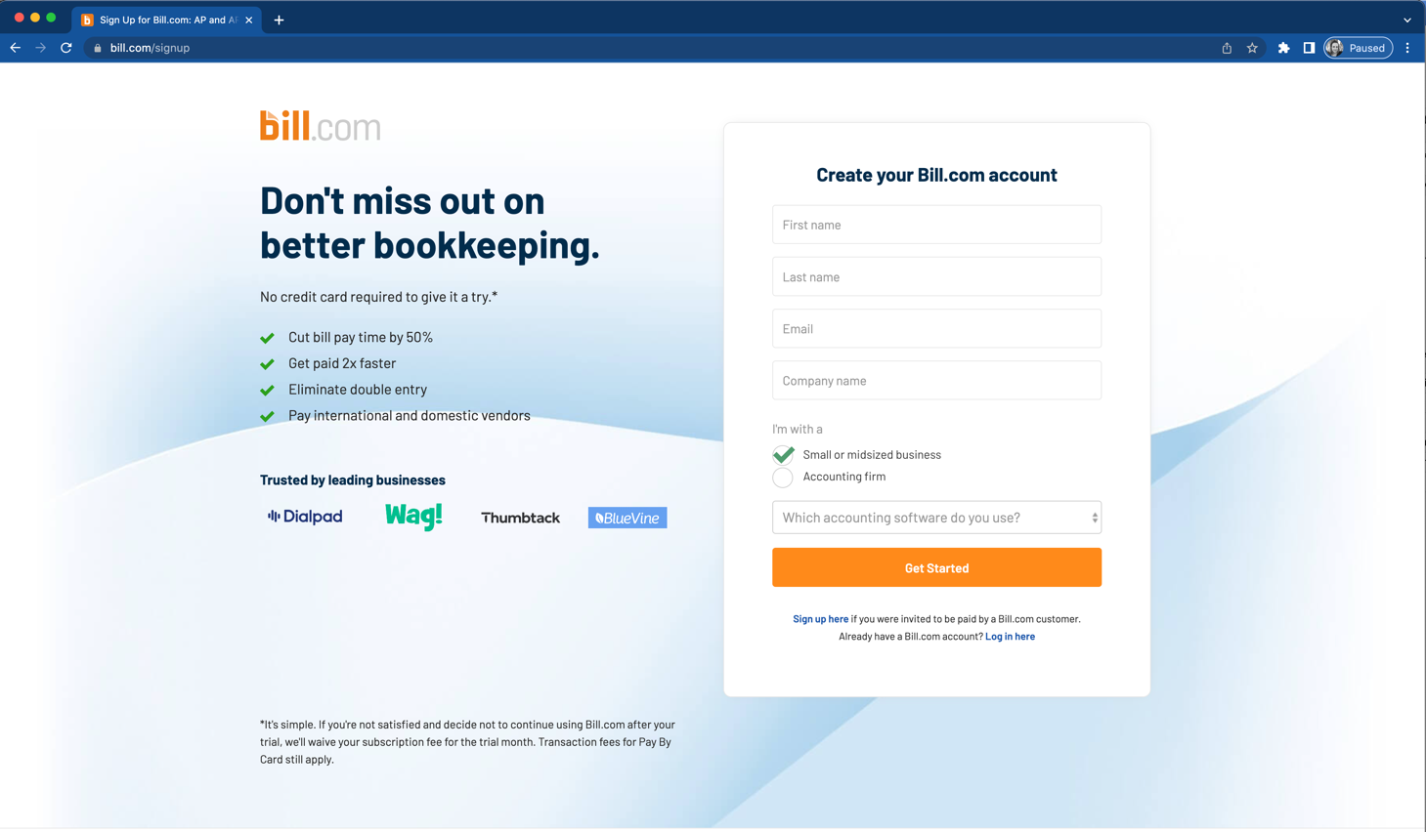

Once you have an established a Bill.com account, you can use the same credentials in our portal and access all invoices that have been assigned to the appropriate Billees. If you click “Pay Outstanding Bills button below (blue arrow) on Bill.com platform

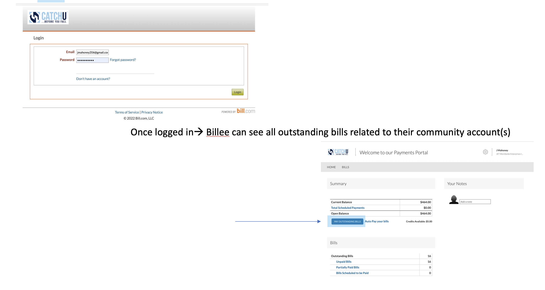
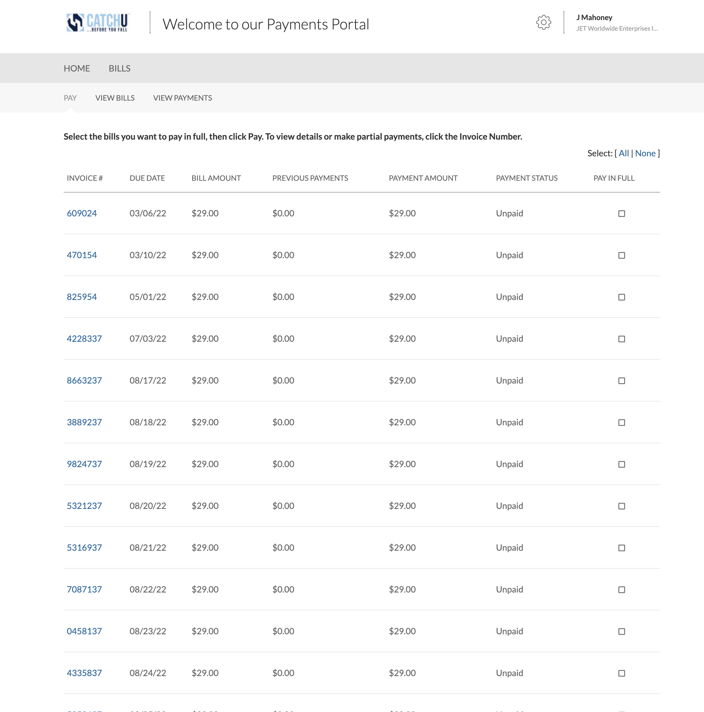
You will then see a list of unpaid CatchU service invoices. Please select each open invoice by clicking on each respective invoice # - like (609024) highlighted in blue above. After clicking each invoice (see sample below), the actual invoice will pop-up. All bills can be paid through the portal after a bank account is added.
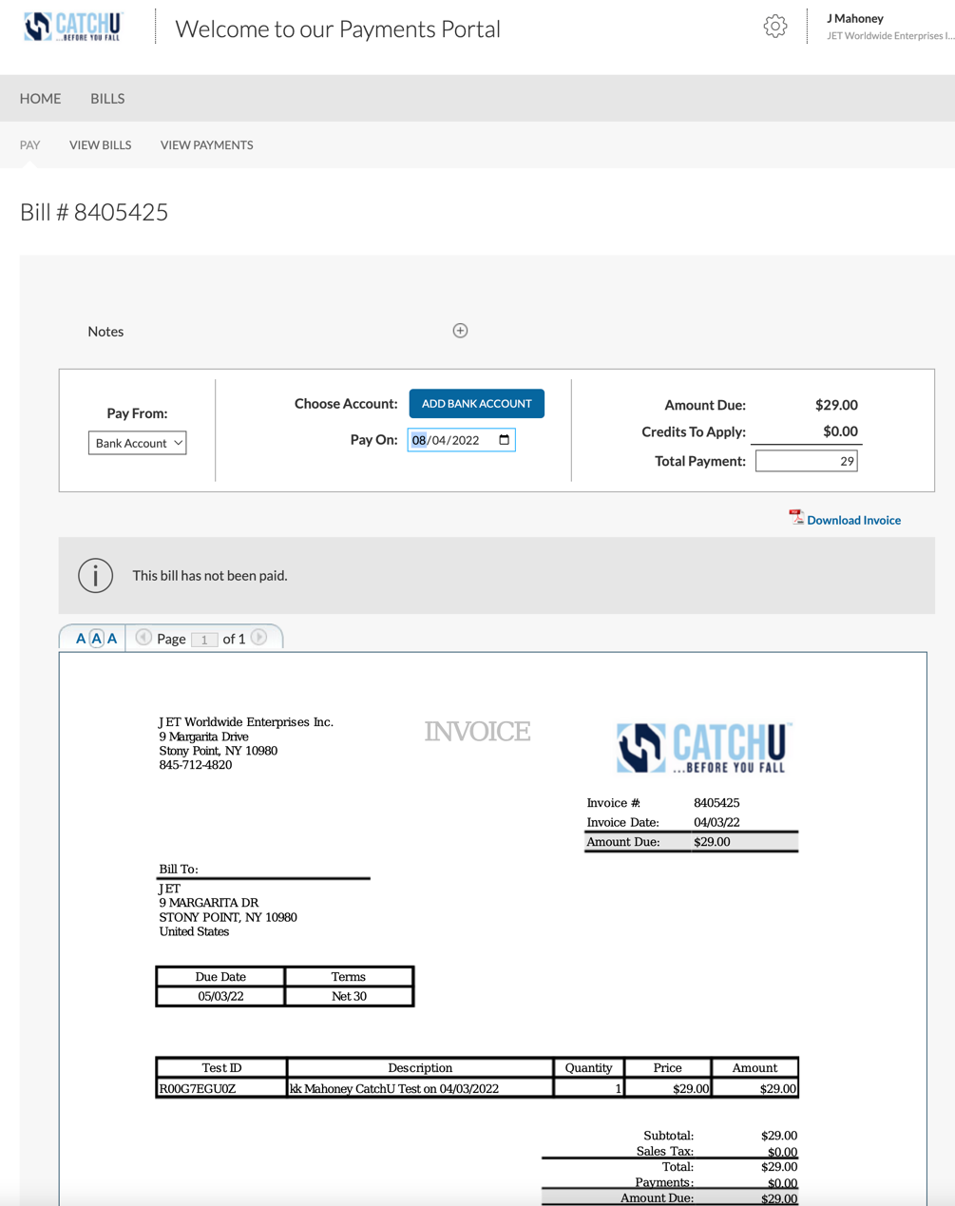

- Support

As previously mentioned, our team is always available! If you have questions, please feel free to email us anytime at support@catchu.net. For additional information and to follow our fall prevention blog http://(www.catchu.net/fallprevention), please visit our website www.catchu.net.

For convenience, we have added a Contact Us feature (below red box) that is directly to the left of your profile name (top right-hand corner of the portal). Click the Contact Us button (red box below) any time that you want to send a direct email to support@catchu.net without having to leave the portal. This feature will allow the CatchU team to know both your Username and the Corporate/Community Account that is in question.

- Glossary

Audit Logs: A record of events and changes made to the specific portal pages. Logs document any and all changes made in the portal by specific usernames so that all portal modifications are tracked.

Bill.com: The online billing platform that sends invoices to customers. Users will need to create a bill.com account to pay for CatchU services. Special billing functionality can be made directly in bill.com: see https://help.bill.com/hc/en-us/categories/115000285666-Account-Fundamentals

CatchU® App: The name of the 1st quantitative falls-screening app for older adults.

Community: This umbrella term refers to individual privates, private practices or assisted living facilities in order to capture many different types of account types that are not linked to a specific corporate account.

Corporate: An account for corporations or larger practices with multiple locations or practices (what we call communities). For these accounts, one corporate location should be created, with each location registered as unique community name under the specific corporate account.

CSV file: A comma separated value (.CSV) file that can be imported to various software programs.

Encrypted: Restricted, blocked and protected.

Fields: Options for different sections or areas of the portal that can be typed in or selected from a choice menu.

Import Functionality: A tool used to add multiple patients, billees, communities, etc from a file rather than manually inputting data one field at a time.

Icon: Small image used to represent concept/functionality.

iPhones List: A tab where a community can list all in-house iPhones that are available for patients to take CatchU. If patient is not taking test remotely, then programmed iPhones for the community will populate and can be selected when creating a test.

Left Side Toolbar: Options displayed on the left side of the portal.

Line items: Items listed in rows across various areas of the portal.

One time password (OTP): A password sent to a secure location that only you have
access to; an additional security feature needed to enter the portal.

Patients: Adults ages 65 and older being asked to complete the CatchU
test.

Permissions/Privileges: Actions the specific users can or cannot perform.

Portal: Our web-based platform that securely stores all customer information.

Profile: A place on the portal that stores important information linked to a specific CatchU account.

Providers: An ordering physician or health care provider in charge of supplying tests to the patient, community or corporate location.

Roles: A way to identify the type of user with certain privileges for the appropriate corporate or community account.

Billees: An individual who is in charge of the financial responsibility of the provider, community or corporation.

Community Admin: The administrator of a community which in itself is a facility
that offers medical and personal services.

Corporate Admin: The administrator of a corporate which has multiple
communities that offer medical and personal services.

Corporate HQ Admin: An individual who is in charge (point contact) of a
corporate location.

Individual Practice Admin: An individual who is independent from a community
or corporate location.

Support Staff: Administrative personnel belonging to a community or
corporate location.

Tests: A 10-minute simple reaction time where patients are asked to respond as quickly as possible to all visually and touch-based targets.

Create Test: After a patient is registered under a specific community, a test can be created for them. First create a test and then when ready to actually test the patient, click initiate test (see next).

Initiate Test: Once a test has been created in the portal, hitting “initiate test” will register the test in the portal and send appropriate text message to the patient alerting them that a CatchU test has been ordered for them.

Group Test: A test conducted in a community or corporation with several
patients participating. This feature allows certain communities to go from room to room to test many patients on CatchU on the same iPhone or Android without a need to register each patient separately in the portal on a computer.

Support Team: Members of the CatchU team that will be able to help you troubleshoot all problems. Should you have any questions, please contact us at support@catchu.net.

Users: An individual who has access to certain portal features based
on their role.

